**Practical: 1 Aim: File System Analysis using The Sleuth Kit (Autopsy). Theory**

Sleuth Kit is a collection of command line tools and a C library that allows you to analyze disk images and recover files from them. It is used behind the scenes in Autopsy and many other open source forensics tools.

There are multiple techniques that could be used to perform the analysis on the files, listed below are the techniques that could be used.

**img_stat:** It displays the details associated with the image files.

**fls**: It displays files and directory in a disk image

**fsstat:** It displays general details of a file system.

**istat:** It displays details of a meta-data structure (i.e. inode).

**Autopsy:** It is a digital forensics platform and graphical interface to [the Sleuth Kit](https://www.sleuthkit.org/sleuthkit/index.php) and other digital forensics too

Autopsy is a digital forensics platform and graphical interface to The Sleuth Kit® and other digital forensics tools. It is used by law enforcement, military, and corporate examiners to investigate what happened on a computer. You can even use it to recover photos from your camera's memory card.

Autopsy is an easy to use, GUI-based program that allows you to efficiently analyze hard drives and smart phones. It has a plug-in architecture that allows you to find add-on modules or develop custom modules in Java or Python.

Easy to Use

Autopsy was designed to be intuitive out of the box. Installation is easy and wizards guide you through every step. All results are found in a single tree

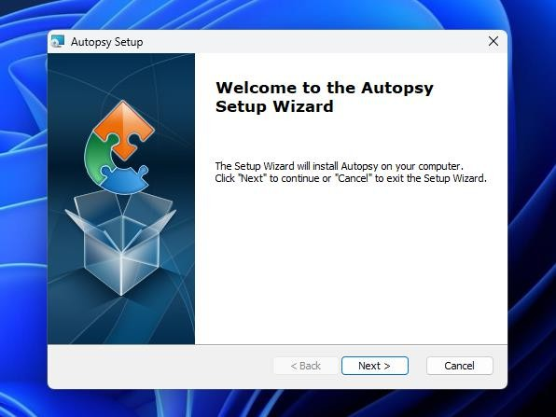

1

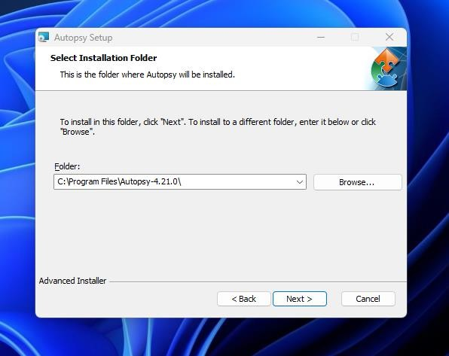

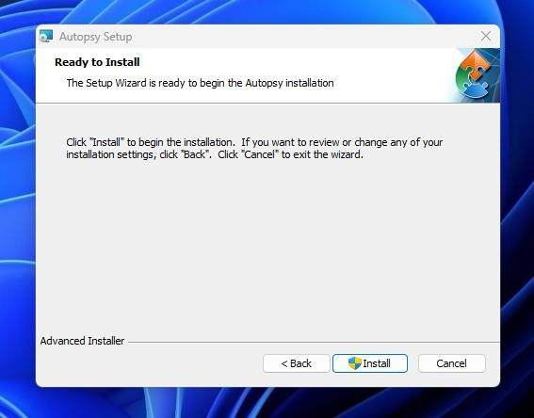

**Step 1- Start a New Case**

**Click New Case. This will add a new case folder to the system and allow you to begin adding evidence. To begin, click New Case.**

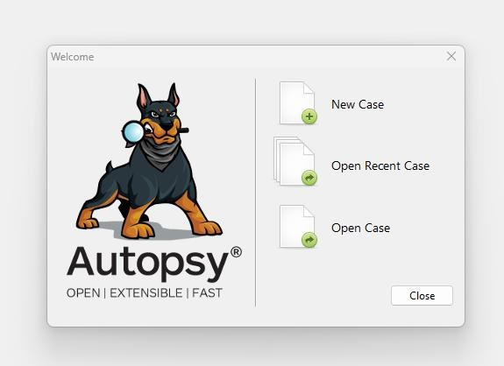

**Step 2-Enter the Case Details**

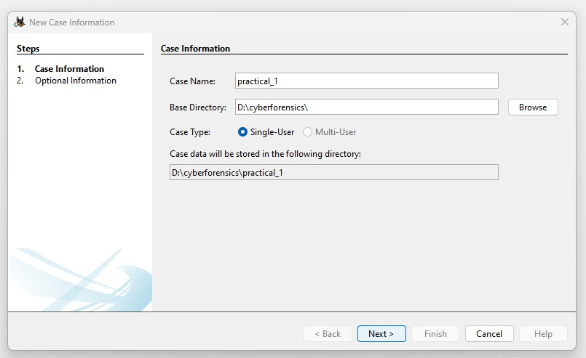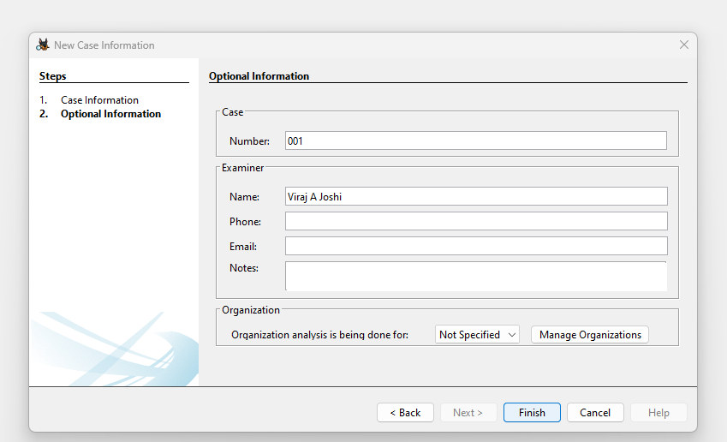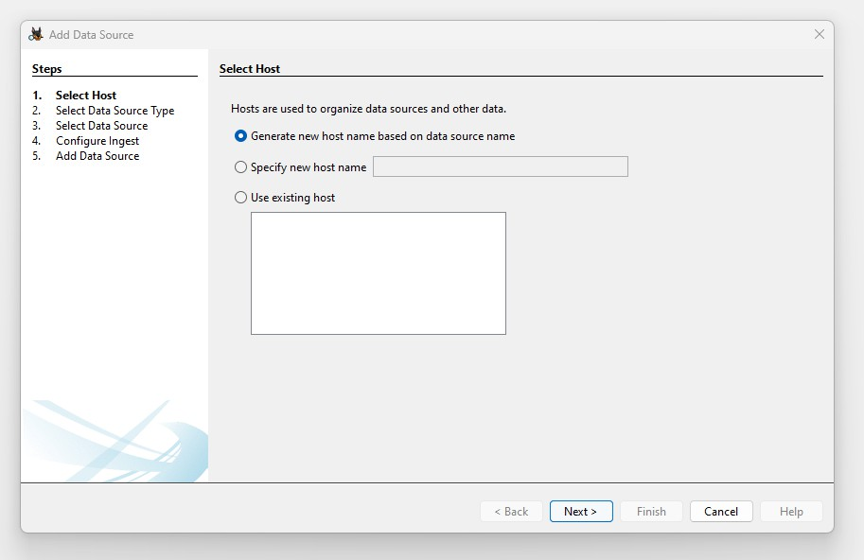

**Step 3 -Choose the path**

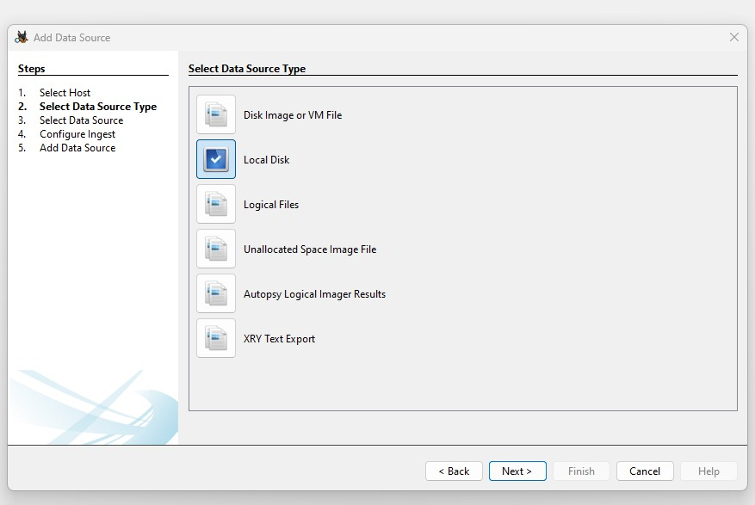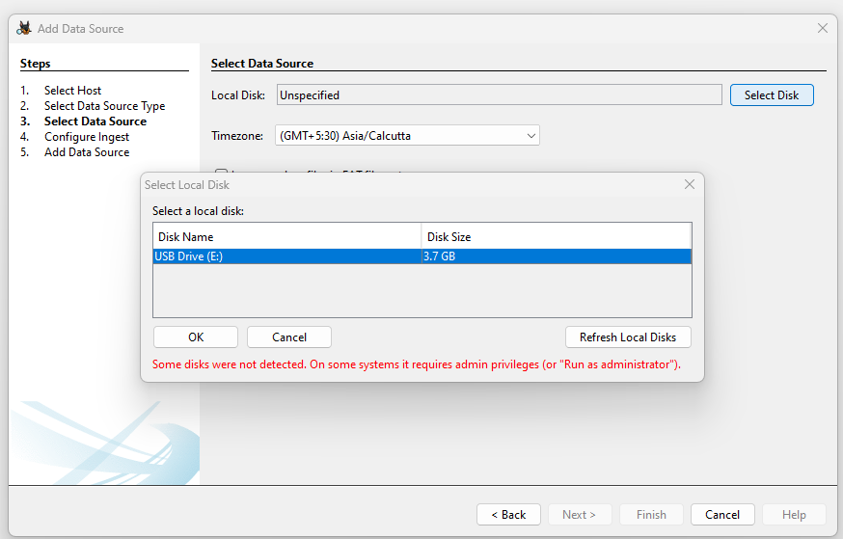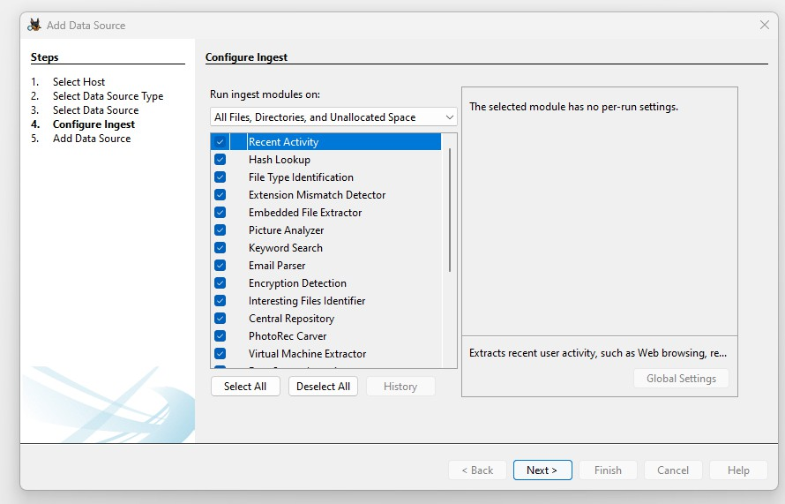

**Step 4 -Retrieve the classified files**

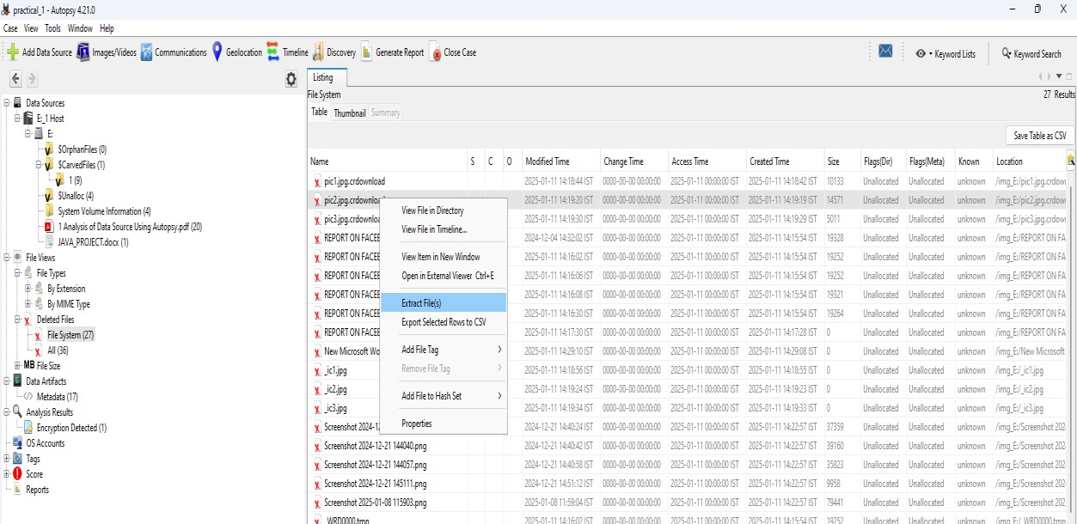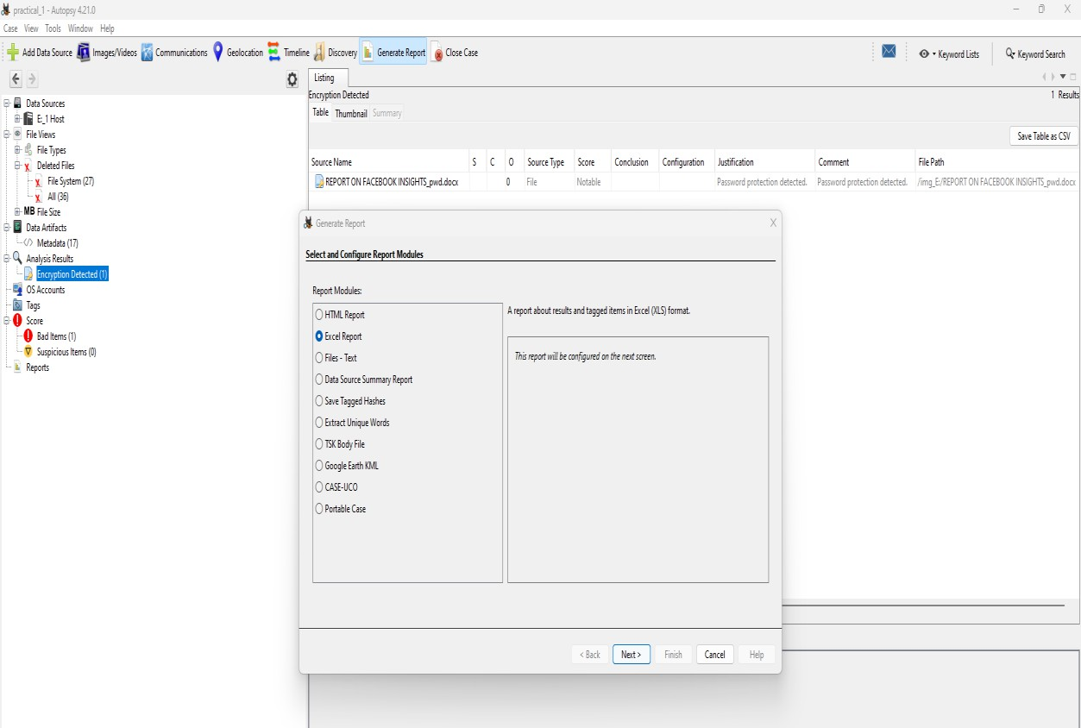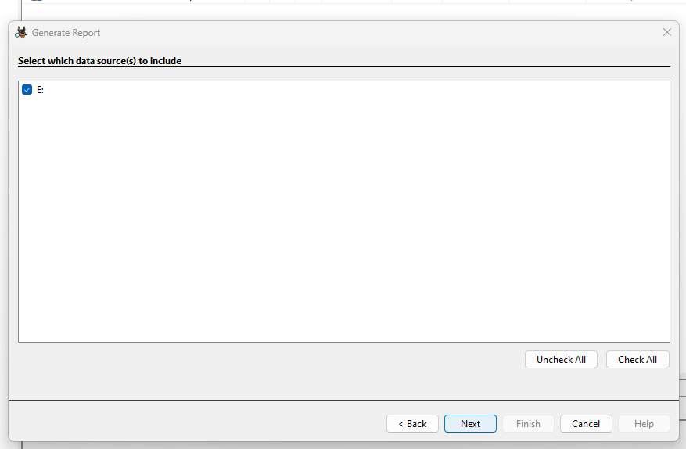

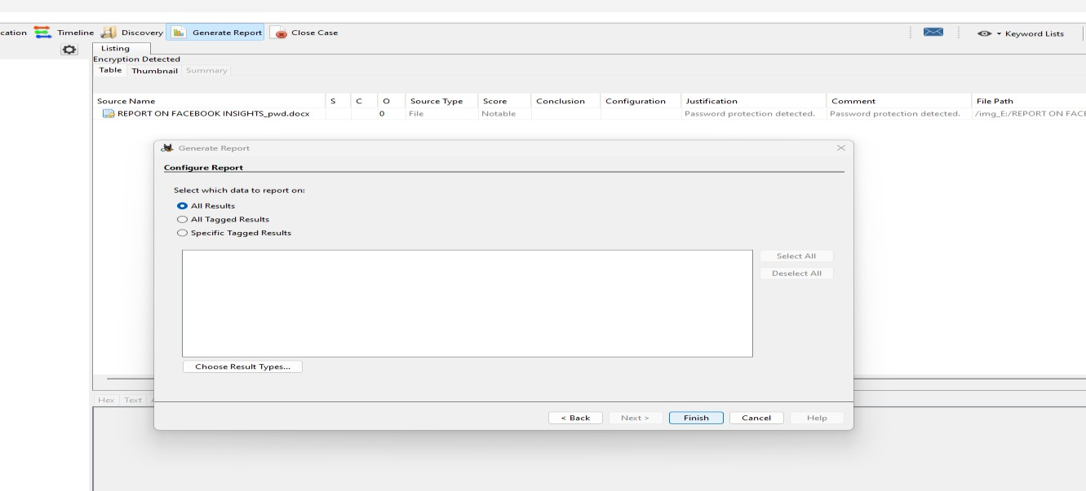

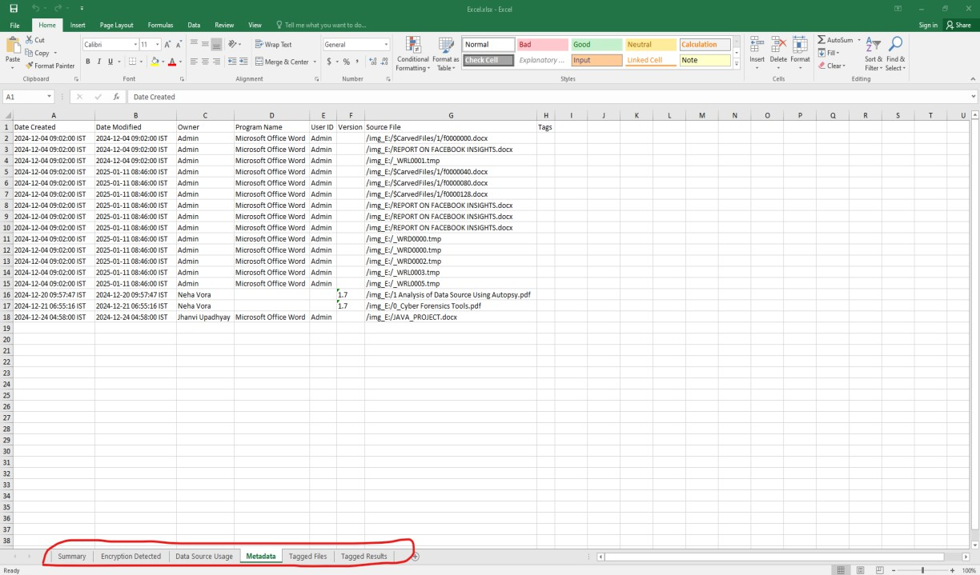

**Practical: 2 Aim: Explore Windows forensic tools (OS Forensics). Theory**

OS Forensics extract forensic data from computers, quicker and easier than ever.

The professional and bootable editions of OS Forensics have many features not available in the free edition, including:

* Import and export of hash sets.
* Customizable system information gathering.
* No limits on the number of cases being managed through OS Forensics.
* Restoration of multiple deleted files in one operation.
* List and search for alternate file streams.
* Sort image files by color.
* Disk indexing and searching not restricted to a fixed number of files.
* No watermark on web captures.
* Multi-core acceleration for file decryption.
* Customizable System Information Gathering.
* View NTFS directory $I30 entries to identify potential hidden/deleted files.

**Code/Demo & Output/Steps:**

Go to: https://[www.osforensics.com/download.html](http://www.osforensics.com/download.html)

**Installing OS Forensics tool**

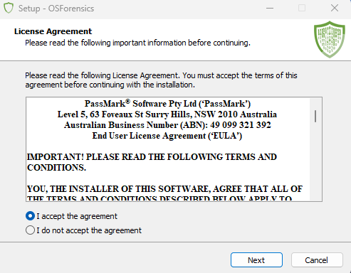

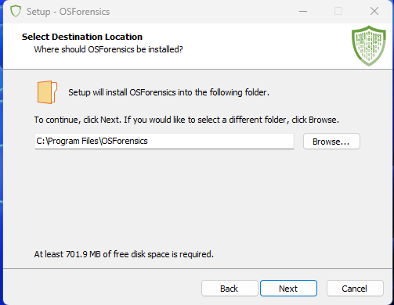

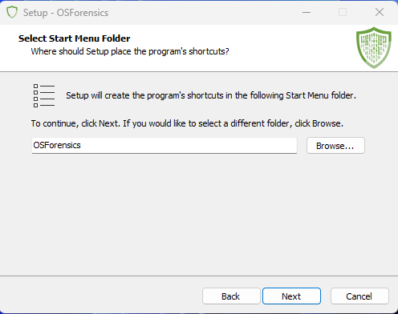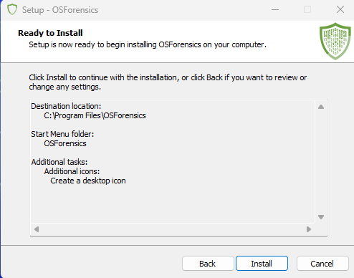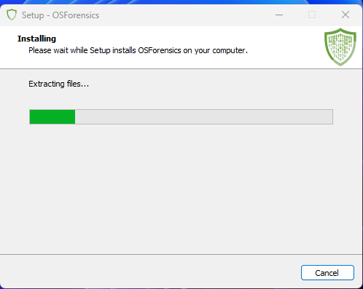

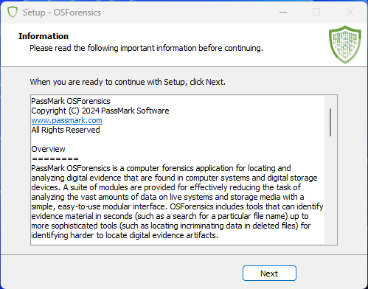

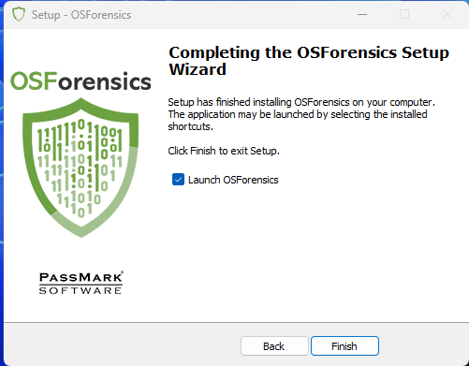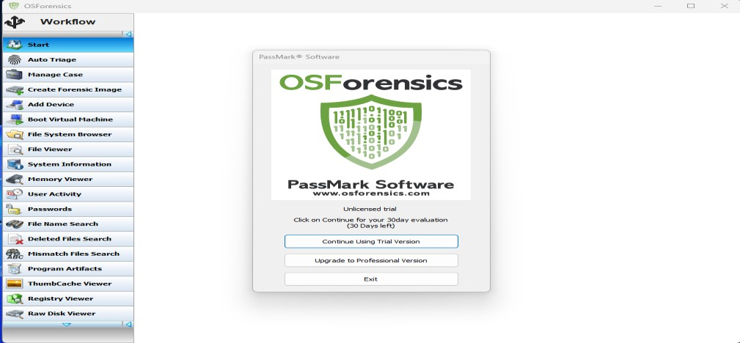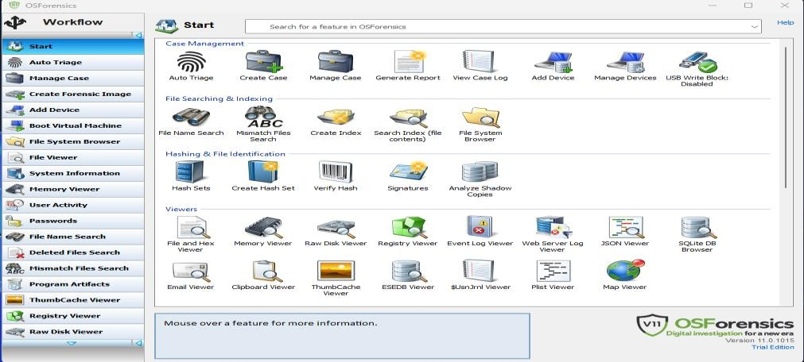

After Successfully installing OS Forensics this kind of interface should be display on your system. OS Forensics supports two methods of gaining access to encrypted office documents.

The first method is for older documents that use 40bit encryption (old XLS, DOC & PDF files).For these documents is it possible to try all possible keys to decrypt the document, with the output being an unencrypted file.

By using this tool we crack password protected files by simply importing the file Select

1. **Password -> Decryption & Password recovery**

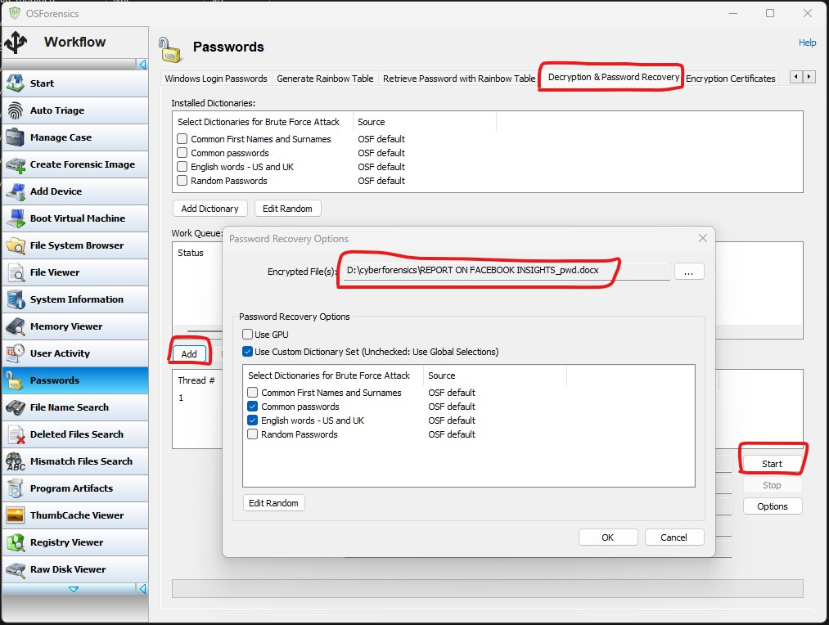

This tool having some preloaded decrypted password file by using unique combination of alpha-numeric. Password combination it is encrypting password protected files.

**Add -> Select password Protected file -> select predefine password libraries -> Start Password is Display in this Prompt**

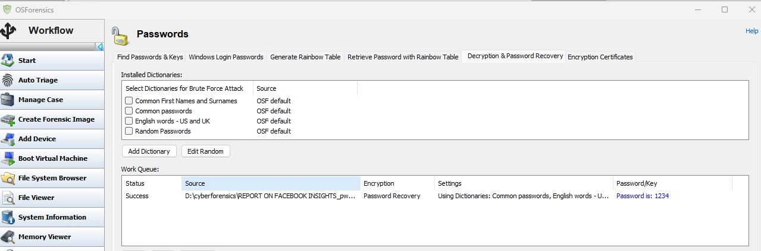

1. **Deleted File Search**

**Select Deleted File Search -> Select Device Drive -> Search**

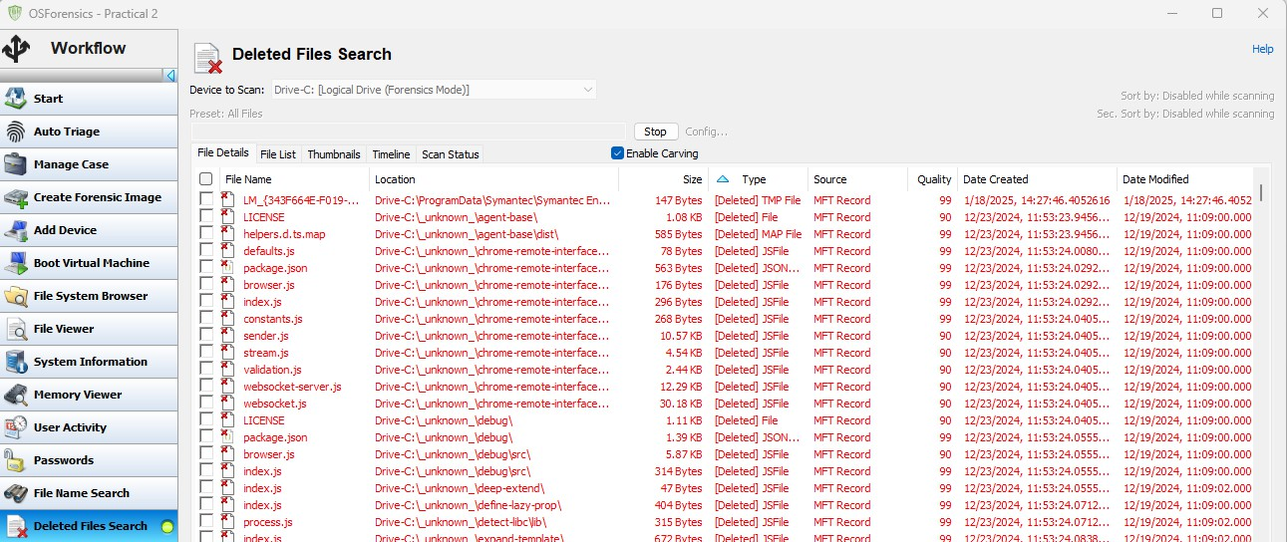

**Select the file that wants to recover by simply right click Checked item -> Save Delete Files on Disk and Select the Folder**

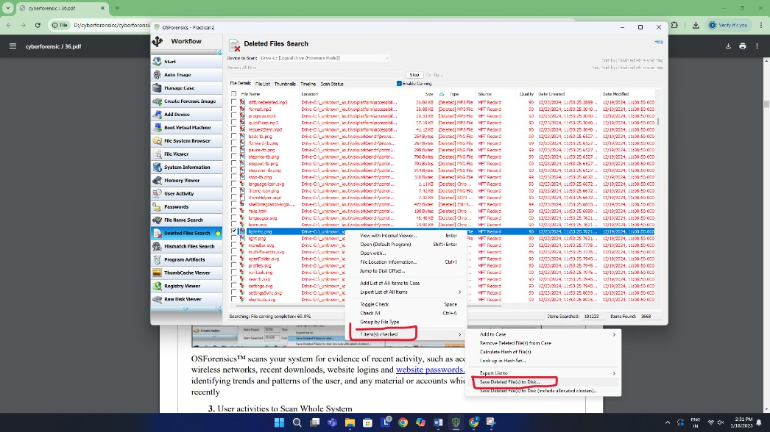

OS Forensics scans your system for evidence of recent activity, such as accessed websites, USB drives, wireless networks, recent downloads, website logins and website passwords. This is especially useful for identifying trends and patterns of the user, and any material or accounts which have been accessed recently

1. **User activities to Scan Whole System**

**Select User Activity -> Select the Drive -> click on scan. Multiple user activities are shown in detailed manner.**

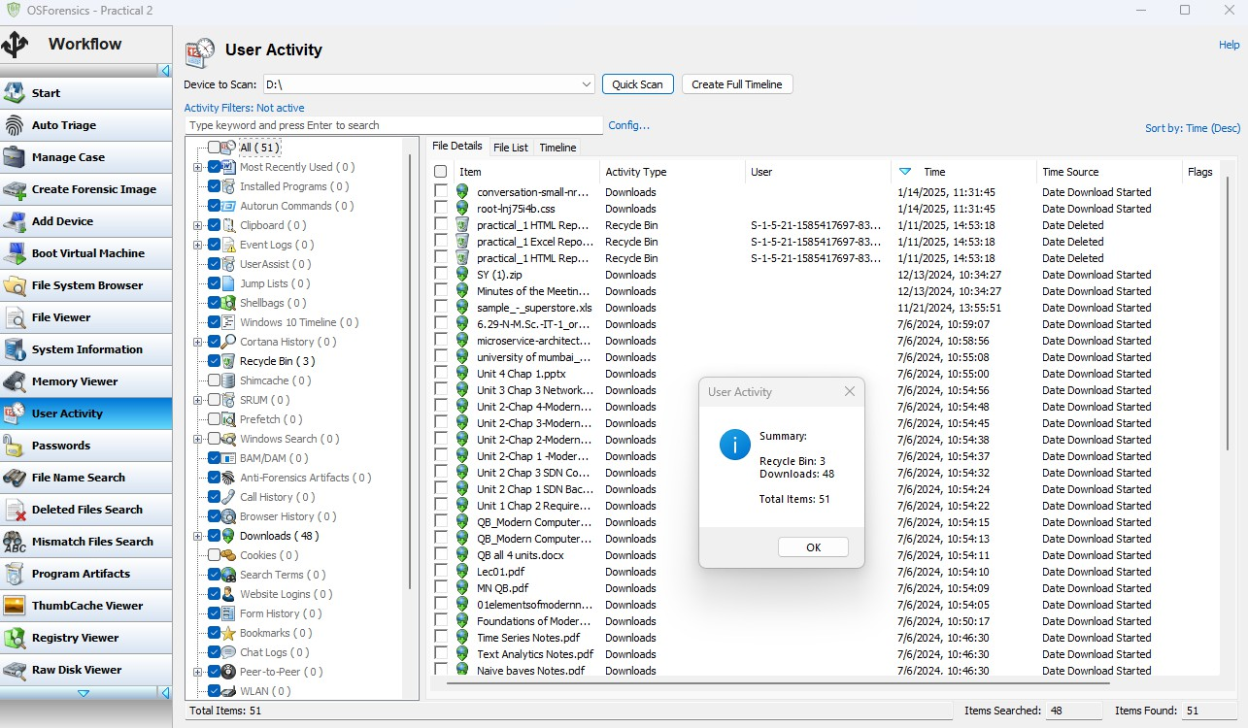

1. **Create a bit-by-bit copy of a drive using OS Forensics in a forensic way. It is use to acquire image of the whole drive.**

**Select forensics imaging -> select the target image file -> ok**

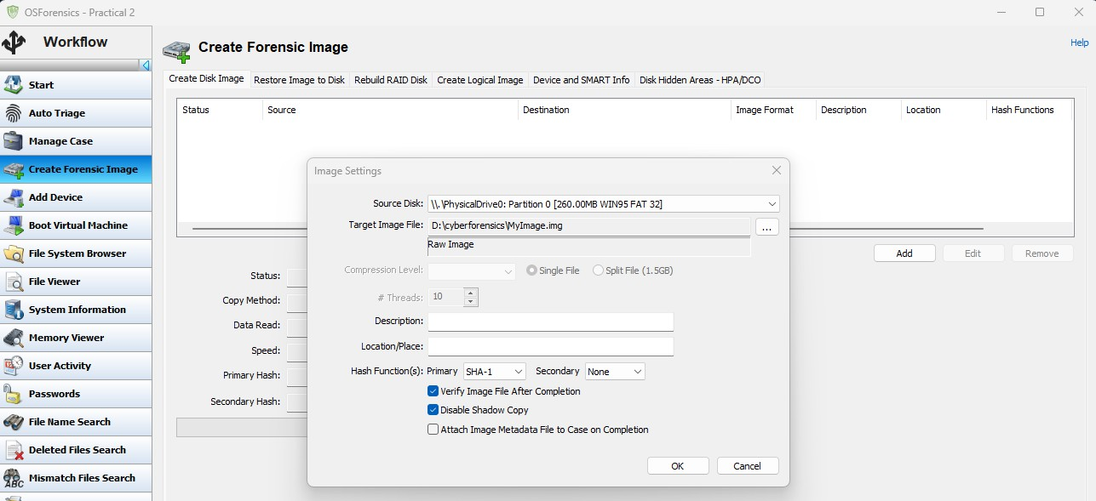

**Practical: 3**

**Aim: Using Forensic Tool Kit (FTK) & Writing report using FTK (Access Data FTK). Step 1-Start a New Case**

**Click New Case. This will add a new case folder to the system and allow you to begin adding evidence. To begin, click New Case.**



**Step 2 -Enter the Case Details**







**Step 3 -Choose the path**







**Step 4 -Retrieve the classified files**









1. **Exploring the data source:**

**The Data Source information: Here the basic metadata is shown. A detailed analysis is displayed in**

**the bottom section. These details can be extracted in the form of Hex values, Results, File Metadata, etc.**

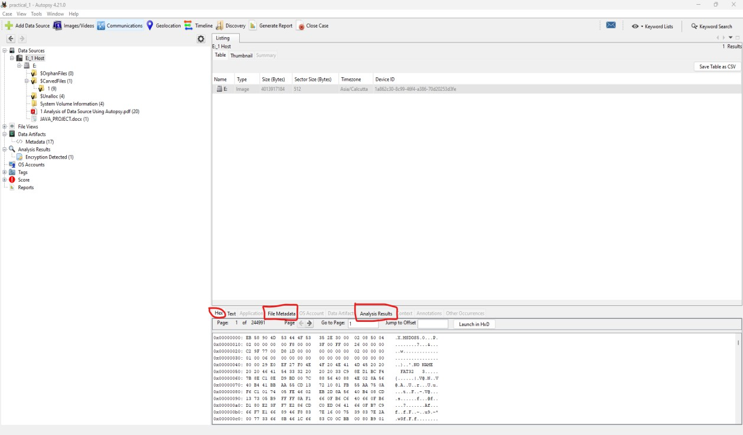

**The disk image is then broken down based upon its partitions.**

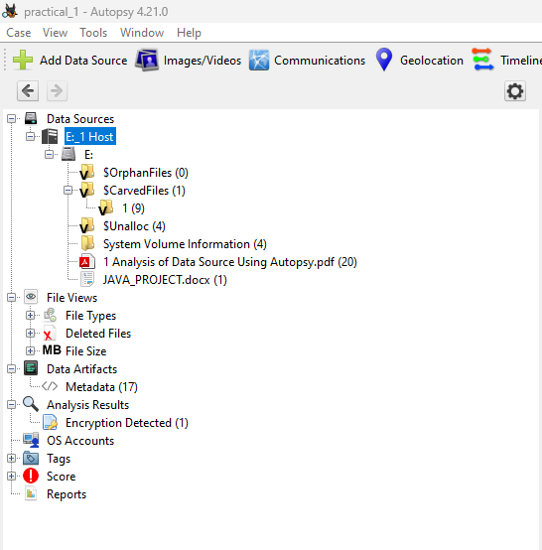

**Each volume can be browsed for its contents, results for which are displayed in the section at the bottom. For example, the content shown below belongs to Data Sources -> System Volume Information (4) -> [Parent Folder].**

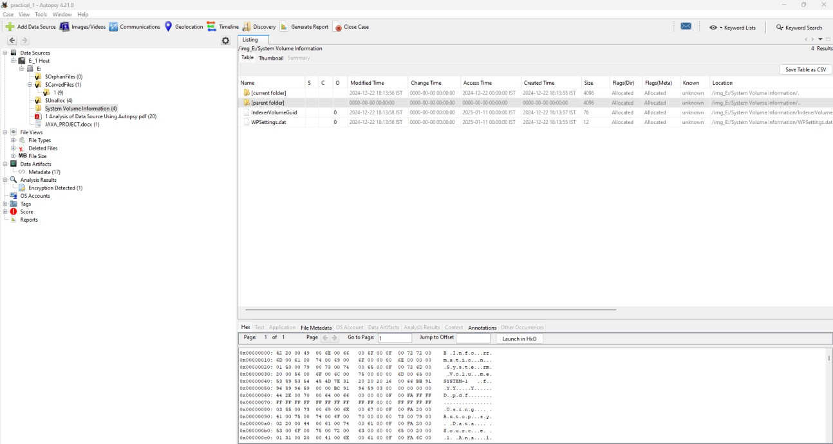

Views (Determines the factor of file classification)

* + **File Type:** Here the files are categorized based upon their type. The classification can be done either on the basis of file extension or MIME type. While both of these provide a hint about how to deal with a file, file extensions are commonly used by the OS to decide what program shall be used to open a file and MIME types are used by the browser to decide

about how to present the data (or by the server on how to interpret the data received). Files displayed here also include the deleted files.

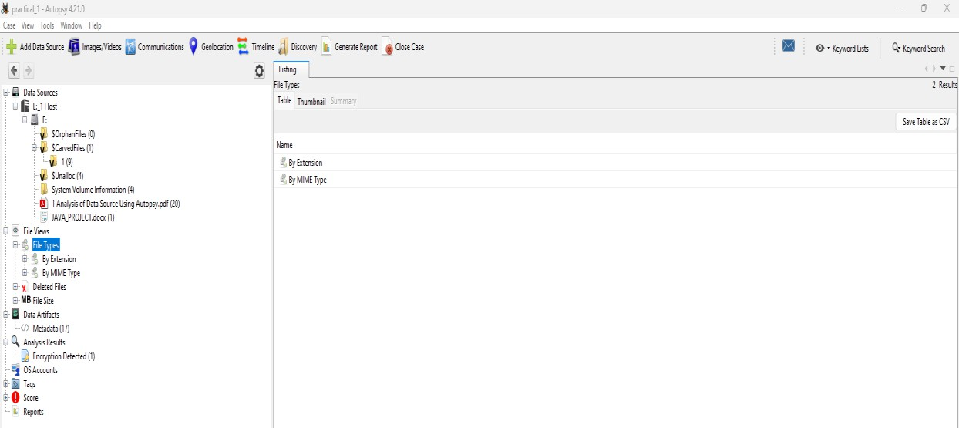

* + **Deleted Files:** Here information about the files that were specifically deleted can be found.

These deleted files can be recovered as well: Right-click on the file to be recovered -> click on Extract File(s). -> Save the file in an appropriate destination.



* + **MB Size Files:** Here files are classified based upon their size. The range starts from 50MB. This enables the examiner to determine exclusively large files.

Note: It is usually advised to not scan or extract any suspected files/ disks such as payload files, etc.

in the main system, rather scan them in safe environments such as a virtual machine, and then

extract the data, as they hold the possibility of being corrupt and may infect the examiner’s system

with viruses.

**Results:**

All the extracted data is viewed in Views/ Data Source. In Results, we get the information about this data.

* + **Extracted Content:** Each Extracted Content displayed below can be further explored. The following briefly explains each of them.
  + **EXIF Metadata:** It contains all the .jpg images that have EXIF Metadata associated with them,

this Metadata can be analyzed further.

* + **Encryption Detection:** It detects files that are password protected/ encrypted.

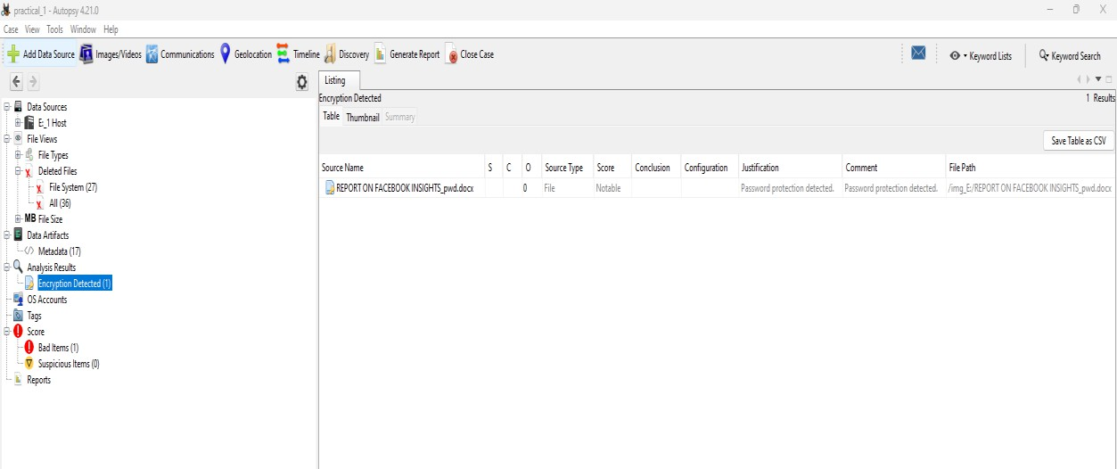

* + **Extension Mismatch Detection:** As explained above, it Identifies the files whose extensions do not match their MIME types and thus they may be suspicious.
  + **Installed Programs:** It gives details about the software used by the user. This information is extracted with the help of the Software Registry hive.
  + **Operating System Information:** It gives information about the OS with the help of the Windows Registry hive and the Software Registry hive.
  + **Operating System User Account:** It lists information about all the user accounts, for example, accounts belonging to the device are extracted from the Software Hive and the accounts associated with the Internet Explorer using index.data files.
  + **Recent documents:** Lists all the documents that were accessed nearby the time the disk image was captured.
  + **Recycle Bin:** Files that are temporarily stored on the system before being permanently deleted are visible here.
  + **Remote Drive:** Shows information about all the remote drives accessed using the system.
  + **Shell bags:** A shell bag is a set of registry keys that stores details about a folder being viewed, such as its position, icon, and size. All the Shell bags from the system can be viewed here.
  + **USB Device attached:** All the information about the external devices attached to the system is displayed here. This data is extracted from Windows Registry which is actually a

maintained database about all the activities taking place on the system.

* + **Web Cookies:** Cookies saves the user information from the sites and thus provide a lot of information about the user’s online activities.
  + **Web History:** All the details about the browser history is shown here.
  + **Web Searches:** Details about the web searches made are displayed here.
  + **Keyword Hits:** Here specific keywords can be looked for in the image of the disk. Multiple data sources can be selected for the lookup. The search can be restricted to Exact match,

Substring match and Regular expression, for example, emails/ IP Addresses, etc.

* + **HashSet Hits:** Here the search can be made using hash values.
  + **E-mail Messages:** Here all the outlook.pst files can be explored.
  + **Interesting Items:** As discussed before, these are the file results based upon the custom rules set by the examiner.
  + **Accounts:** Here all the details regarding the accounts present on the disk are shown. This disk has the following EMAIL accounts.
  + **Reports:** Reports about the entire analysis of the data source can be generated and exported in many formats.







Additional Features:



* + **Add a Data Source:** Each case can hold multiple Data Sources.
  + **Images/Videos:** Images/ Videos in the data source can be viewed in Gallery View. The information here is displayed in the form of attribute-value pairs.

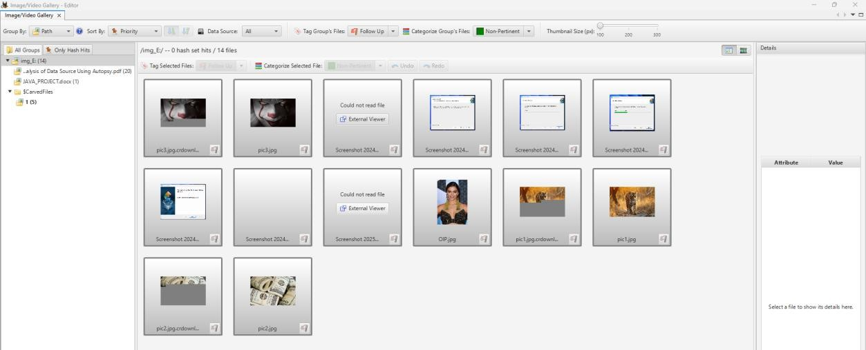

* + **Communications:** All the communications made using the source device are displayed here. This device had communications only in the form of emails.
  + **Geolocation:** This window displays the artifacts that have longitude and latitude attributes as waypoints on a map. Here the data source has no waypoints.
  + **Timeline:** Information about when the computer was used or what events took place before or after a given event can be found, this greatly helps in investigating events near about a

particular time.

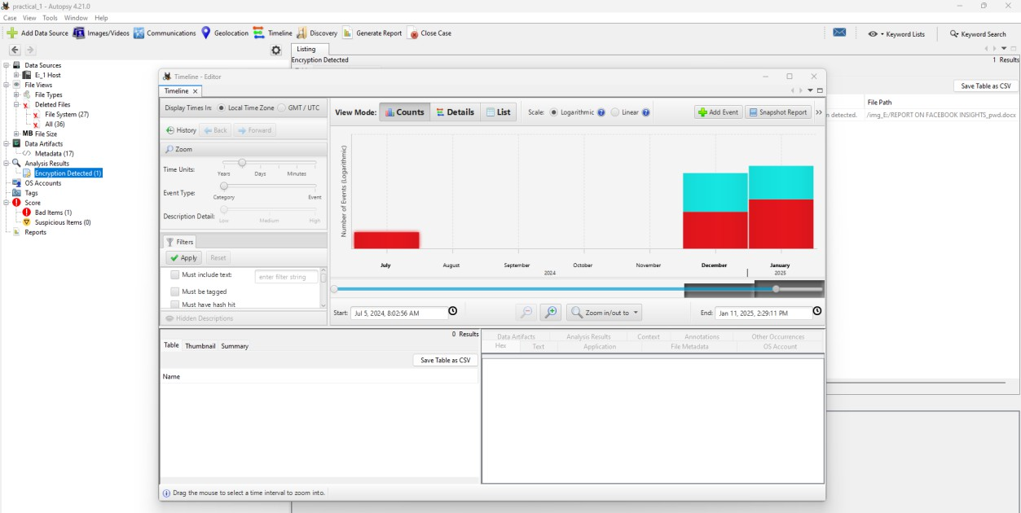

**Practical: 4 Aim: (A) Creating a Forensic Image using FTK Imager Theory**

A Forensic Image is most often needed to verify the integrity of the image after an acquisition ofa Hard Drive has occurred. This is usually performed by law enforcement for court because, aftera forensic image has been created, its integrity can be checked to verify that it has not been tampered with. The image is an identical copy of all the drive structures and contents.

Need for a Forensic Image

In today’s world of crime, many cases have been solved by using this technique, as evidence apart from what is available through an operating system, has been found using this technique, as incriminating data might have deleted to prevent discovery during the investigation. Unless that data is overwritten and deleted securely, it can be recovered.

One of the advantages includes the prevention of the loss of critical files.

When you suspect a custodian of deleting or altering files. A complete forensic image will, to a certain extent, allow you to recover deleted files. It can also potentially be used to identify files that have been renamed or hidden.

What Is FTK Imager?

FTK Imager is a tool for creating disk images and is absolutely free to use. It was developed by The Access Data Group. It is a tool that helps to preview data and for imaging.

With FTK Imager, you can:

Create forensic images or perfect copies of local hard drives, floppy and Zip disks, DVDs, folders, individual files, etc. without making changes to the original evidence. Preview files and folders on local hard drives, network drives, floppy diskettes, Zip disks, CDs, and DVDs.

**Step 1: Installing FTK Imager**

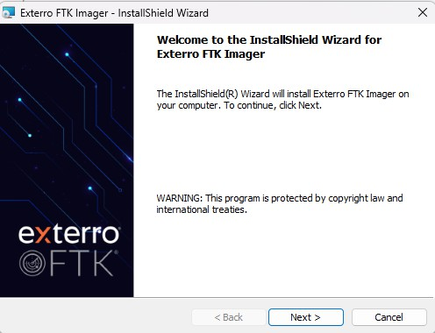

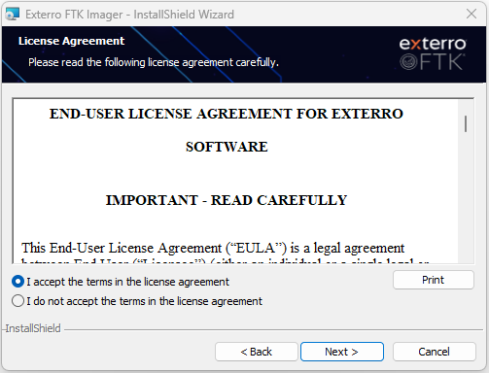

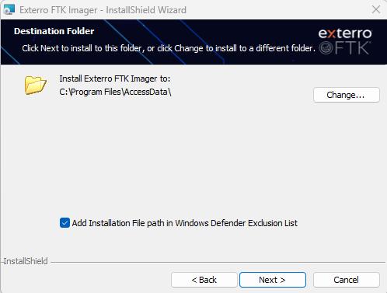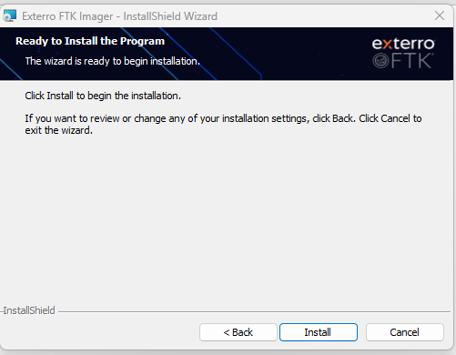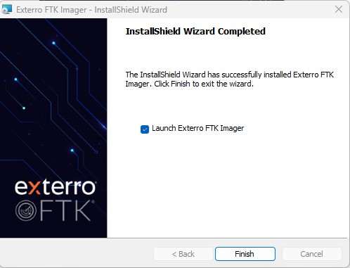

**Step 2: Open the Access Data FTK Imager.**

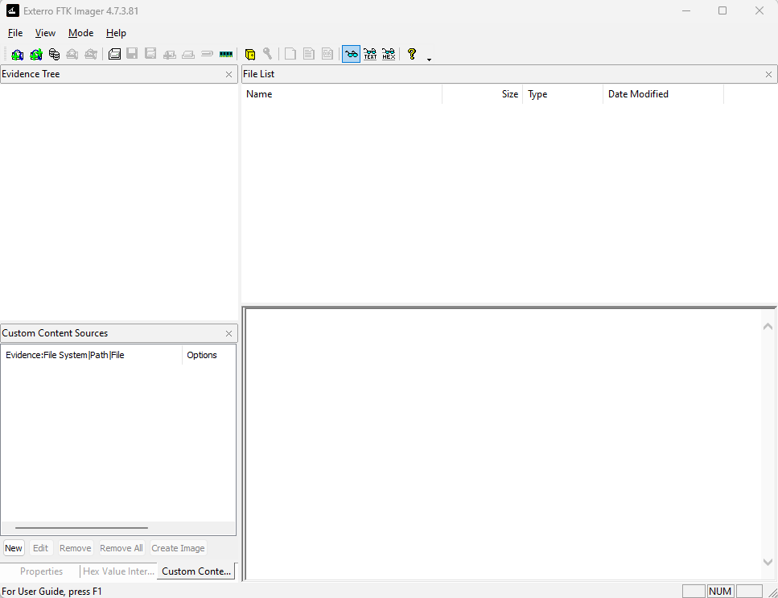

**Step 3: Click File, and then Create Disk Image, or click the button on the tool bar.**

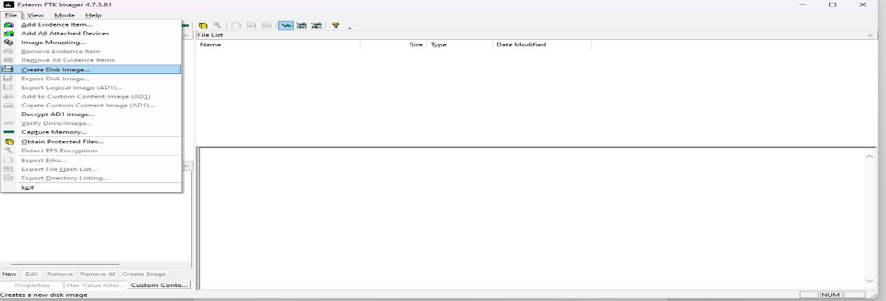

**Step 4: Select the source evidence type you want to make an image of and click Next.**

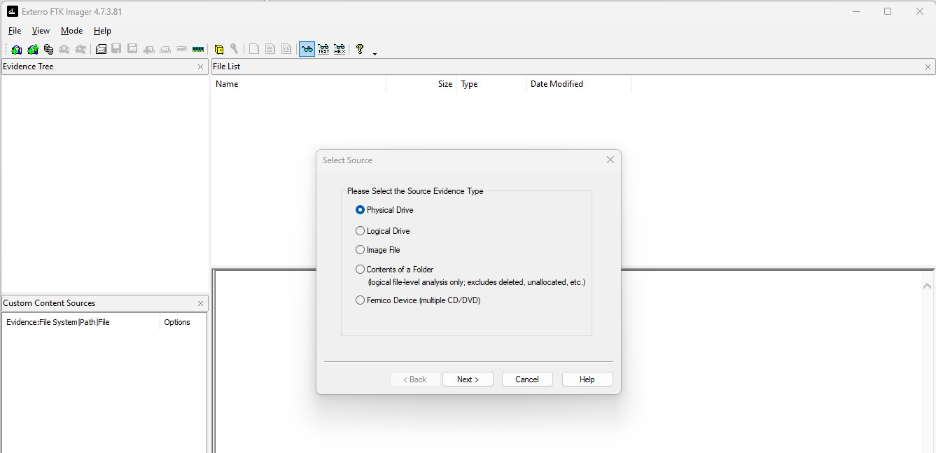

**Step 5: Select the source evidence file with path.**

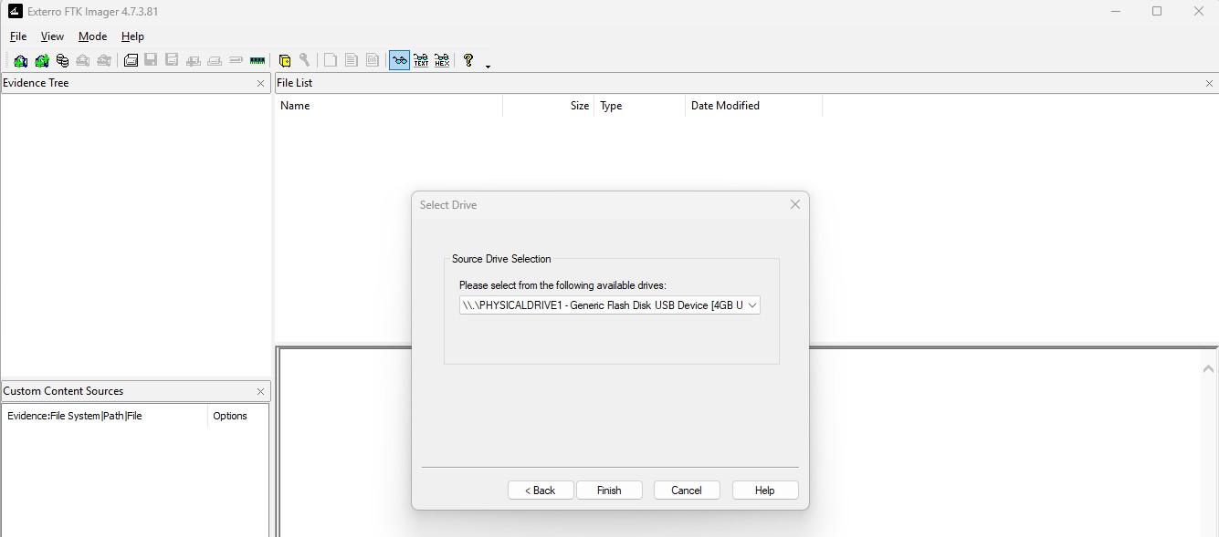

**Step 6: Click on “add” to add image destination**

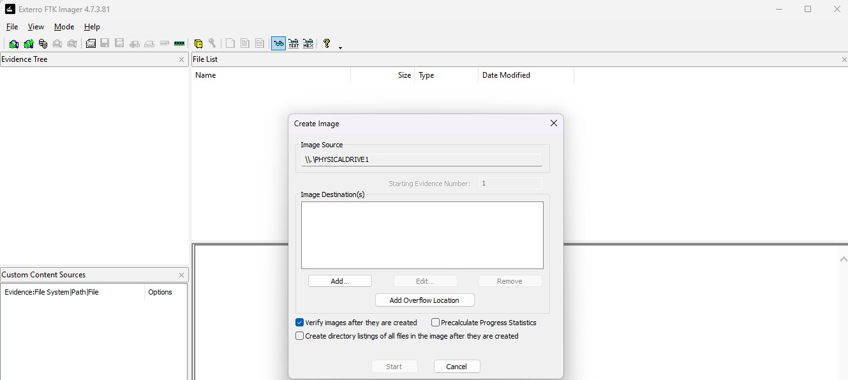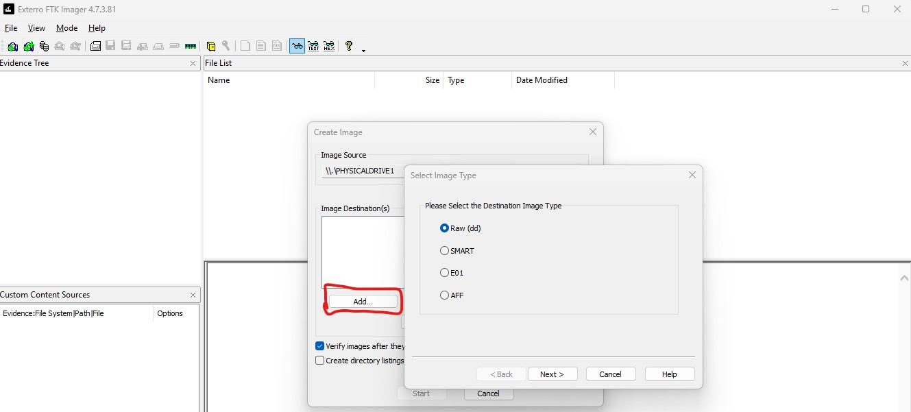

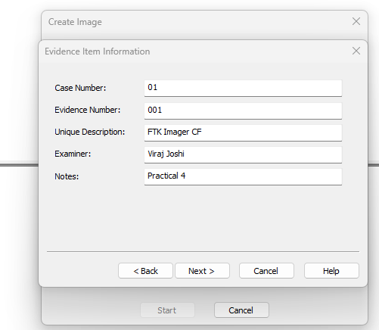

In the Image Destination Folder field, type the location path where you want to save the image file, or click **Browse** to find to the desired location.

**Note:** If the destination folder you select is on a drive that does not have sufficient free space to store the entire image file, FTK Imager prompts for a new destination folder when all available space has been used in the first location. In the Image Filename field, specify a name for the image file but do not specify a file extension.

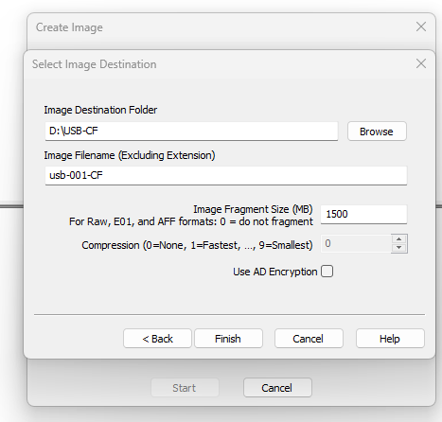

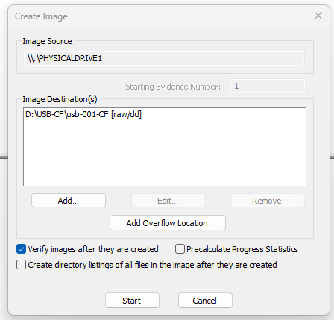

**Step 7: After adding the image destination path click on finish and start the image processing.**

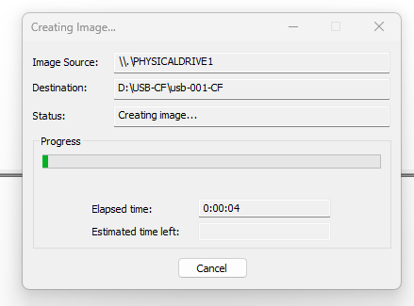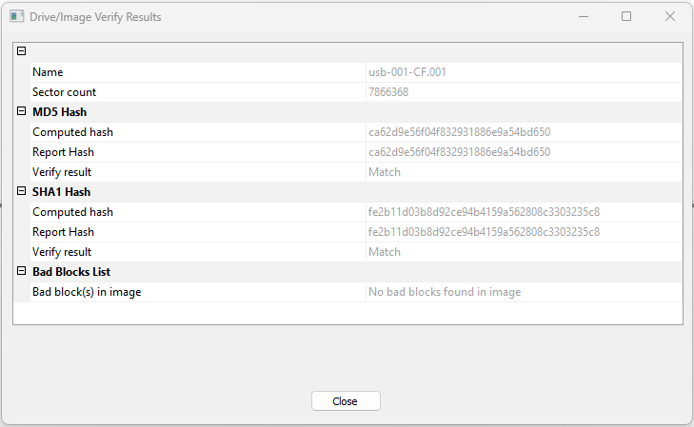

**Step 8: After the images are successfully created, click Image Summary to view detailed file information, including MD5 and SHA1 checksums.**

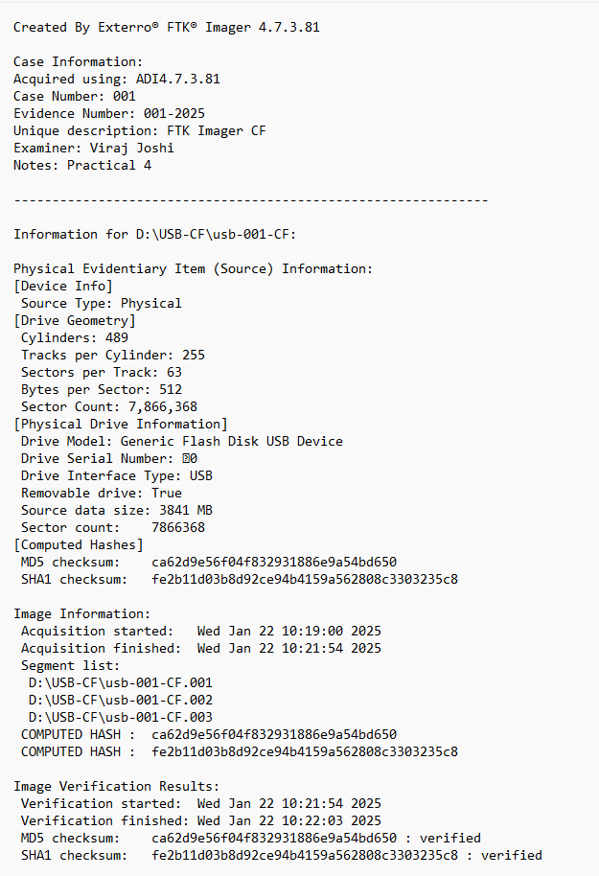

**Step 9: Image mounting**

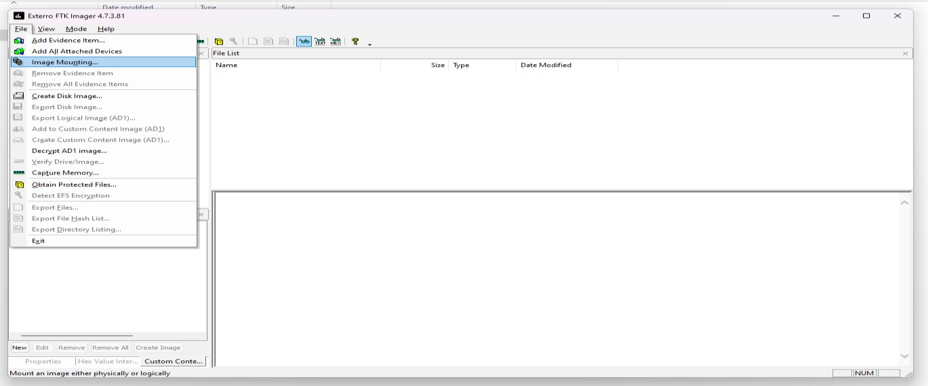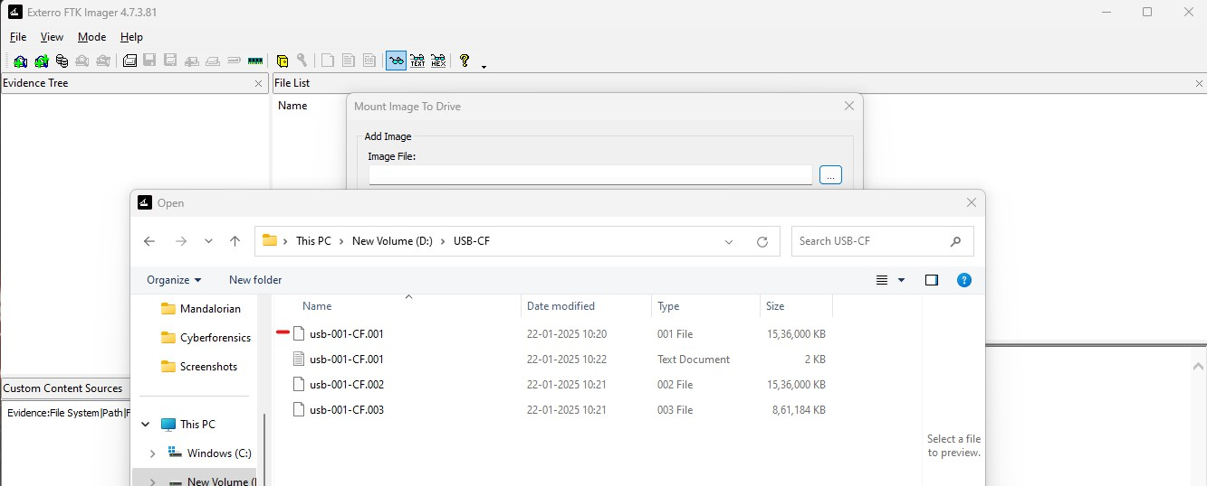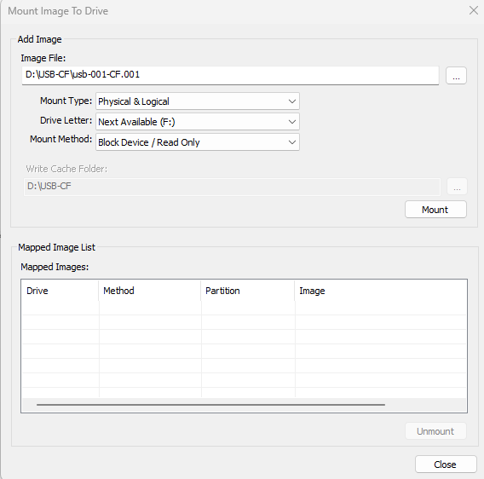

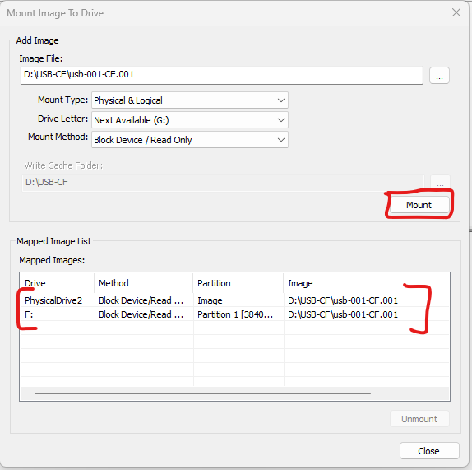

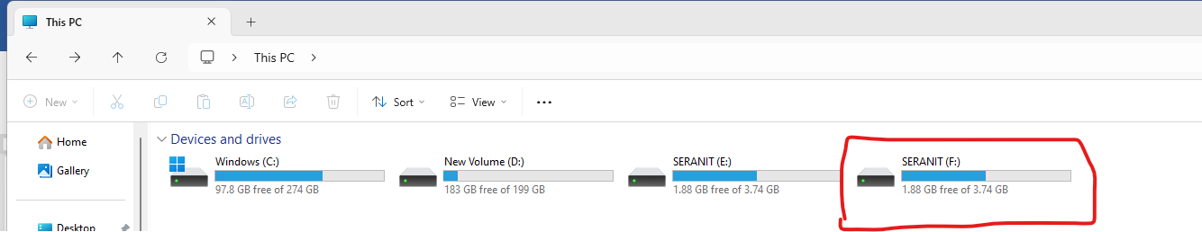

Step 10: Now select the source evidence type as Logical disk

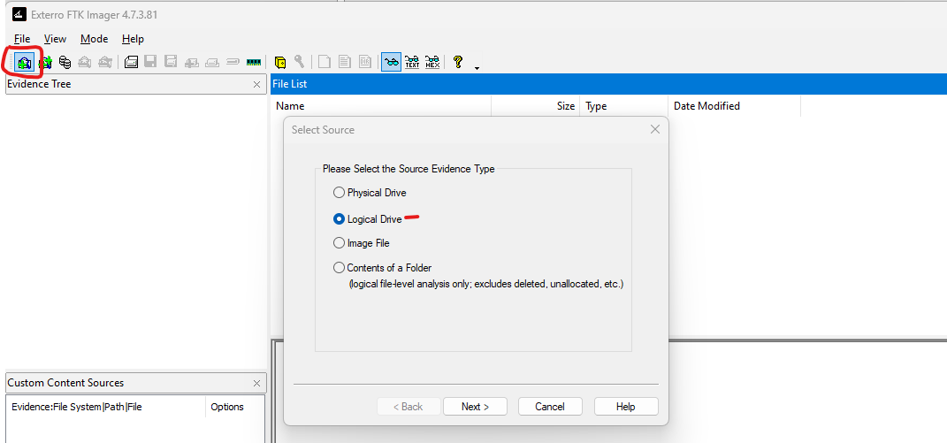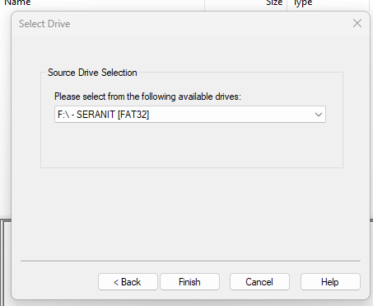

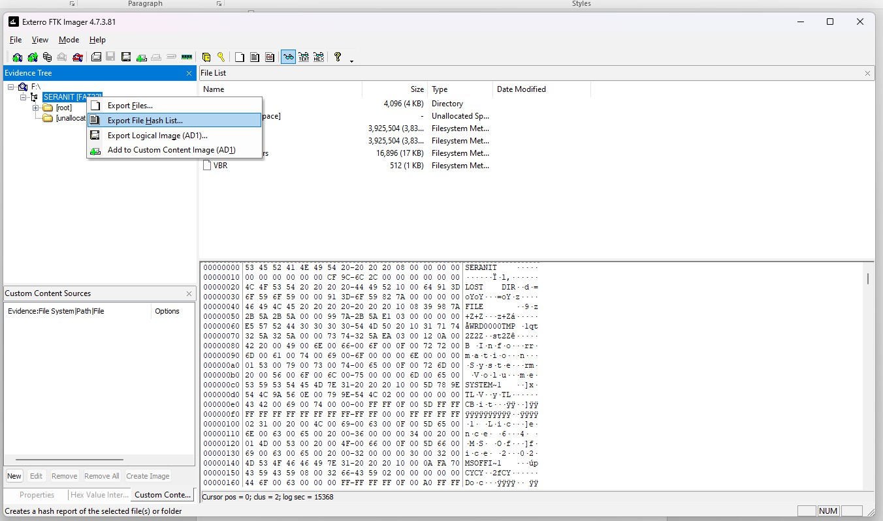

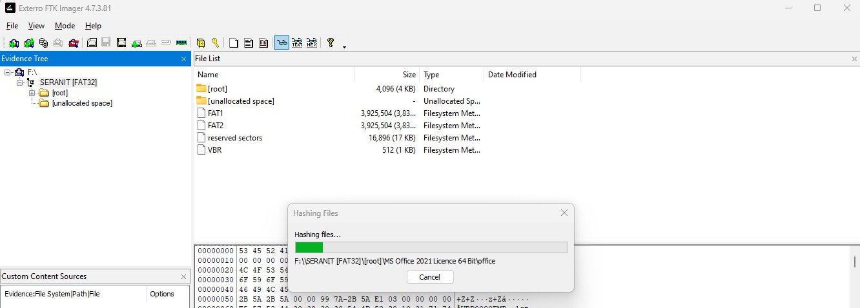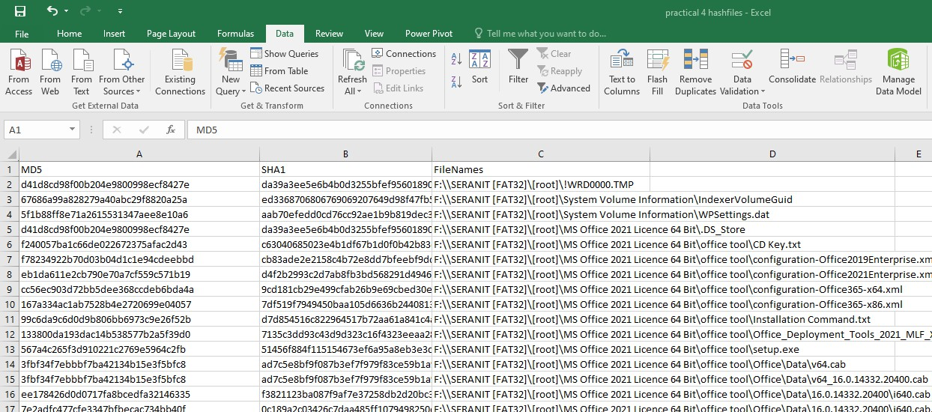

**B) Encryption detection using FTK imager Step 1: Create a folder name Secret**

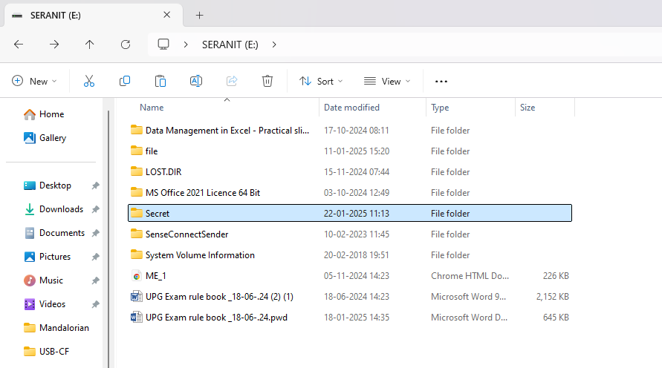

**Step 2: Create a textfile**

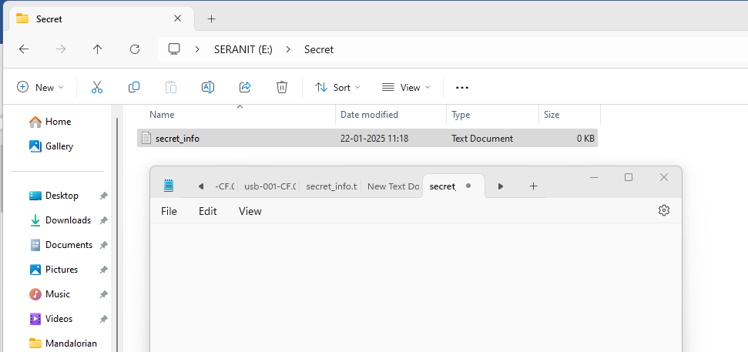

**Step 3: Go to properties, select advanced and click on Encrypt content to secure data**

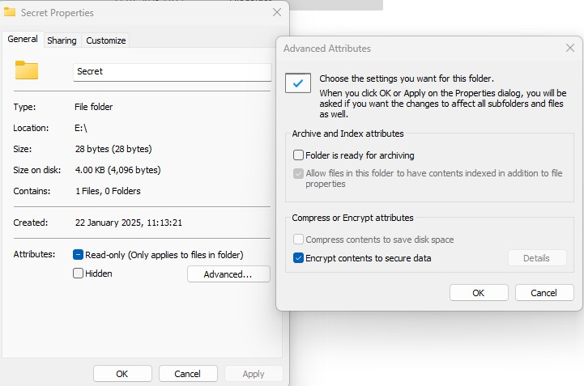

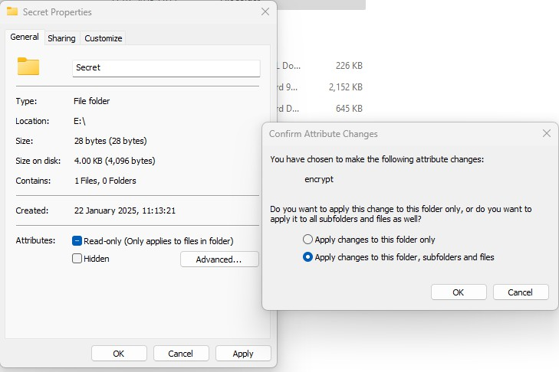

**Step 4: Now open FTK Imager**

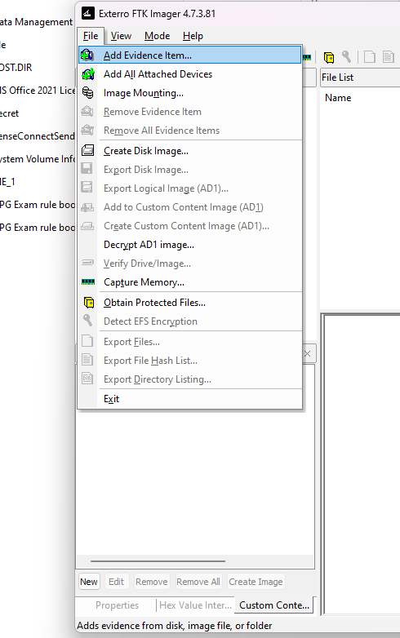

**Step 5: Add the physical drive**

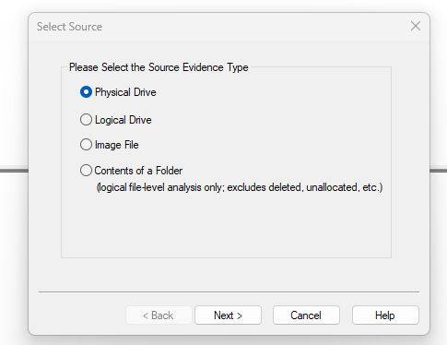

**Step 6: Select your USB**

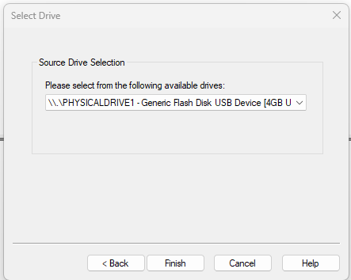

**Practical: 5**

**Aim: (A)Web Attack Detection Problem Statement: Detecting web attack on the data packets.**

**Theory**

Wireshark is a packet sniffer and analysis tool. It captures network traffic on the local networkand stores that data for offline analysis. Wireshark captures network traffic from Ethernet, Bluetooth, Wireless (IEEE.802.11), Token Ring, Frame Relay connections, and more. Wireshark allows you to filter the log either before the capture starts or during analysis, so youcan narrow down and zero into what you are looking for in the network trace

**Steps: Here we have used Sample Packets for Detection form** [**https://www.malware-**](https://www.malware-traffic-analysis.net/)[**traffic-analysis.net/**](https://www.malware-traffic-analysis.net/)

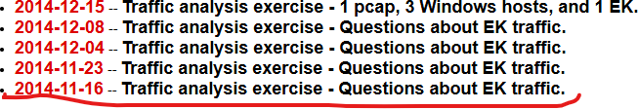

**Choose the file. Enter password: infected_20141116**

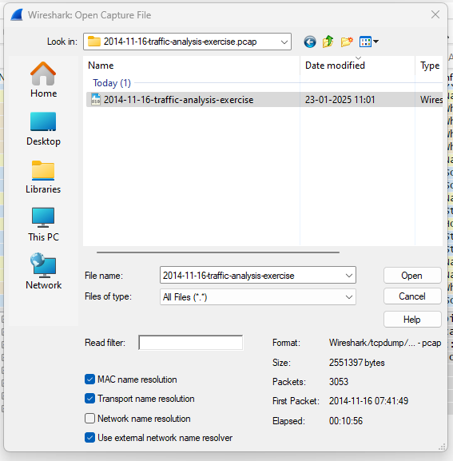

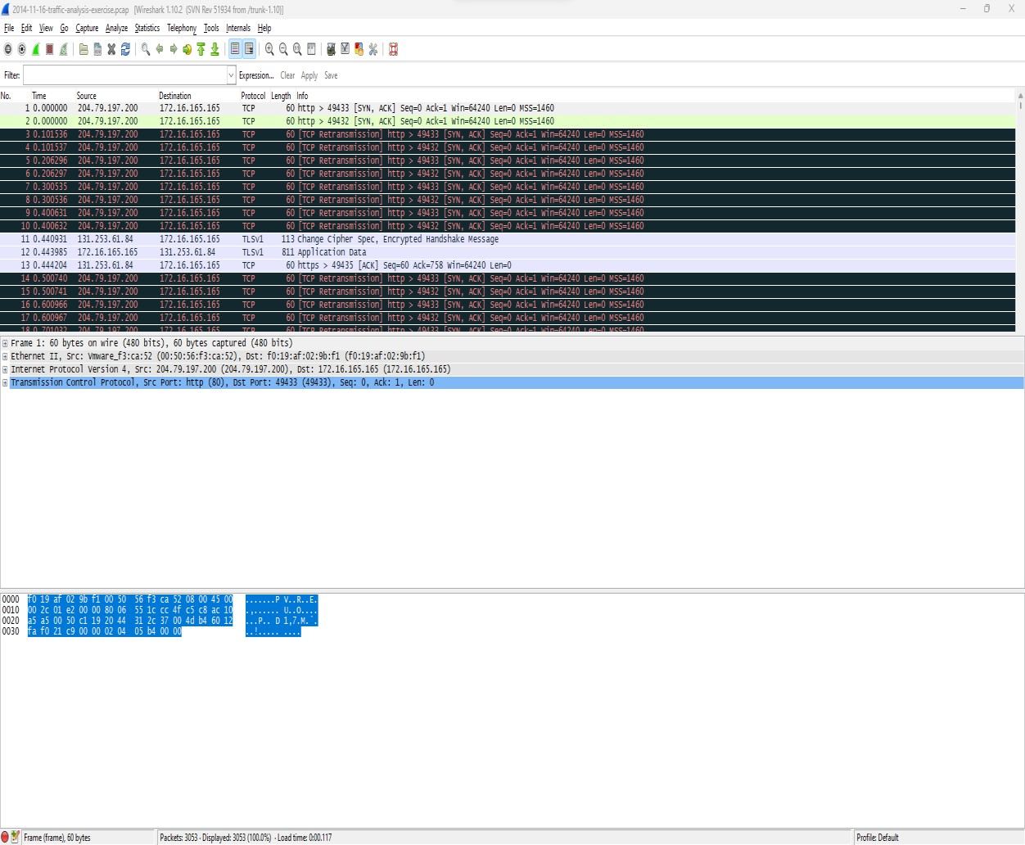

**We have filter the packets. Now only http packets are only been displayed.**

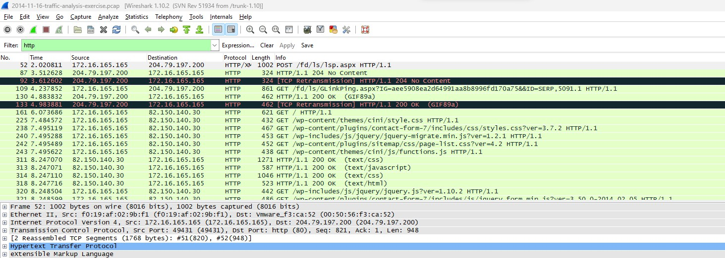

**Narrow down the search to http.request which will show only the GET/POST requests**

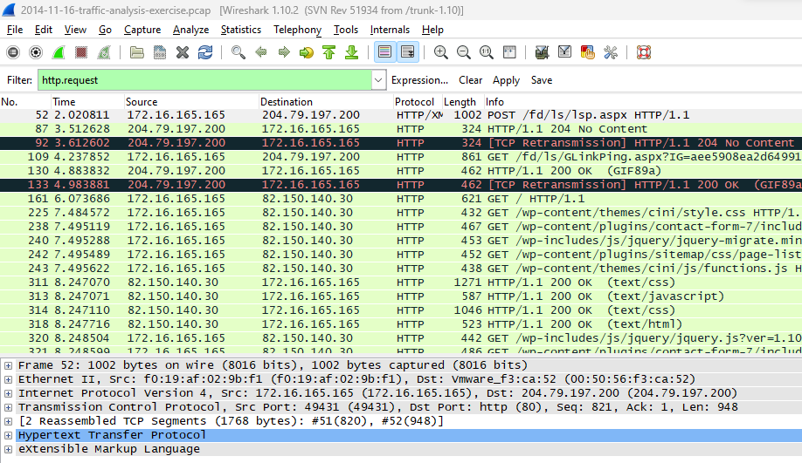

**Now go to File -> Export Objects -> HTTP You will get a Window like this Here you will see all the HTTP objects which are downloaded in this Packet**

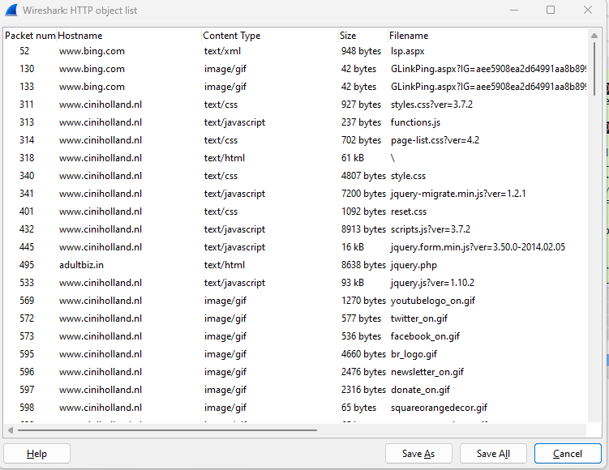

**Will see from above objects weather the file is affected or not by selecting the file to detect the virus Select the java file and click on save. Save the file with extension .jar**

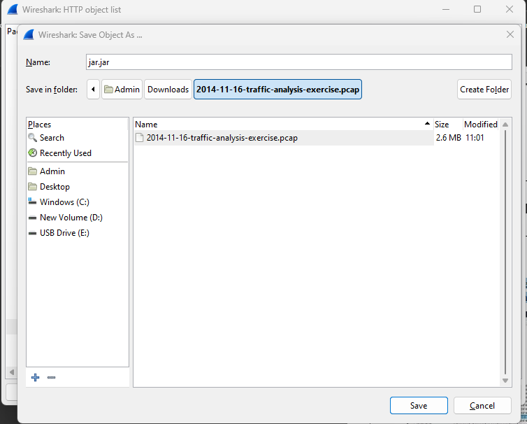

**Similarly select other two files and save it one by oneExtension .exe**

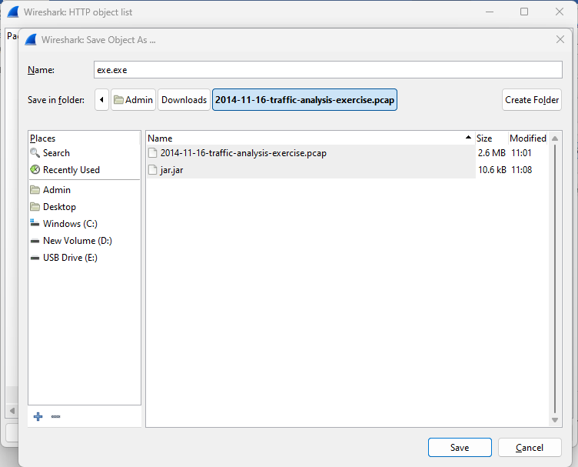

**Extension .swf**

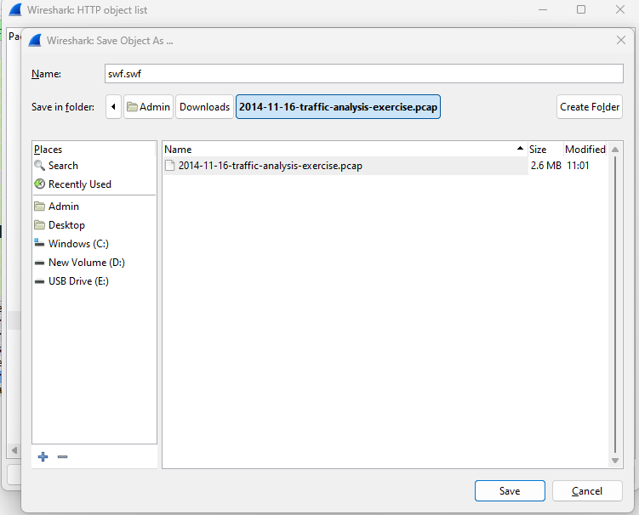

**When you are looking for malware, use content and application type of file. So, here we have used java, executable and shockwave flash files. All files are saved in the system.**

**Go to browser and open virustotal.com**

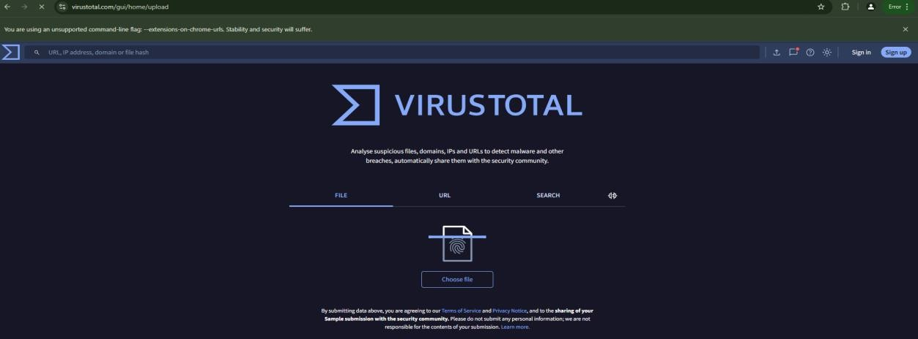

**Click on choose file select the .jar file which was saved earlier**

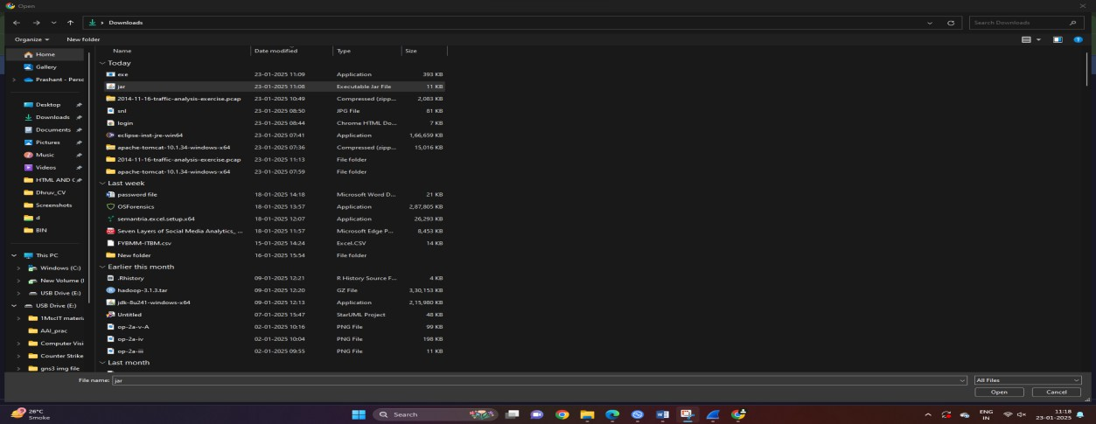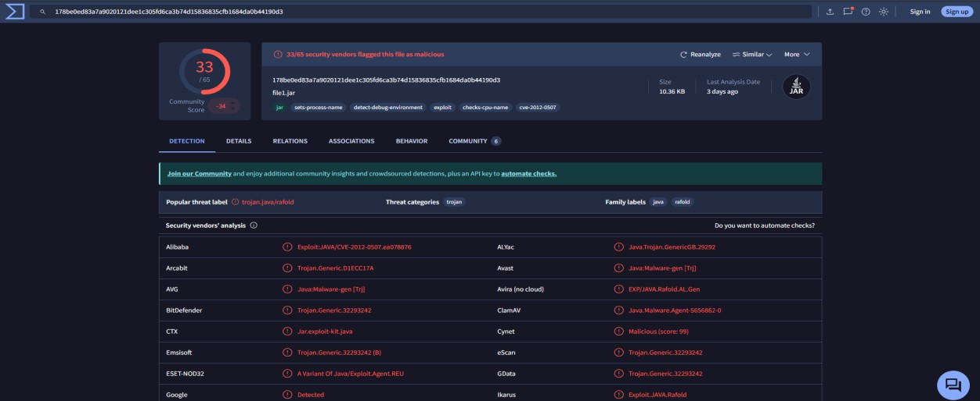

**Click on choose file select the .exe file which was saved earlier**

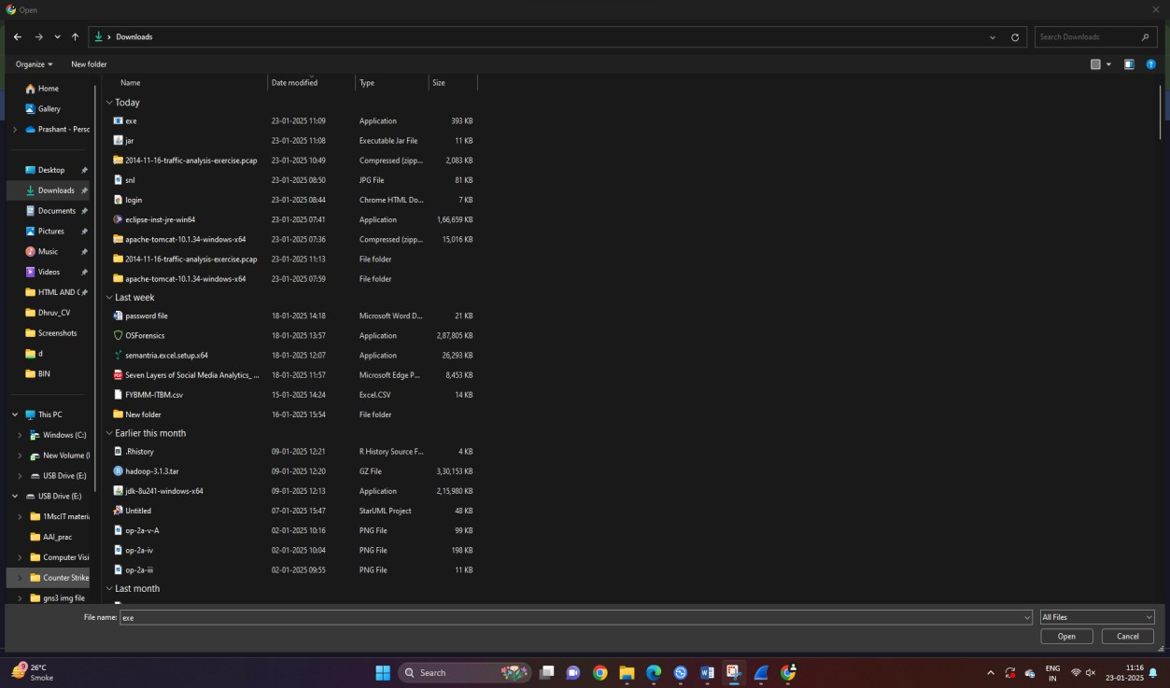

**Click on open Virus total will calculate the hash value of the file and then detects whether the files is malicious or not. Here the malicious attack has been detected. It is infected file.**

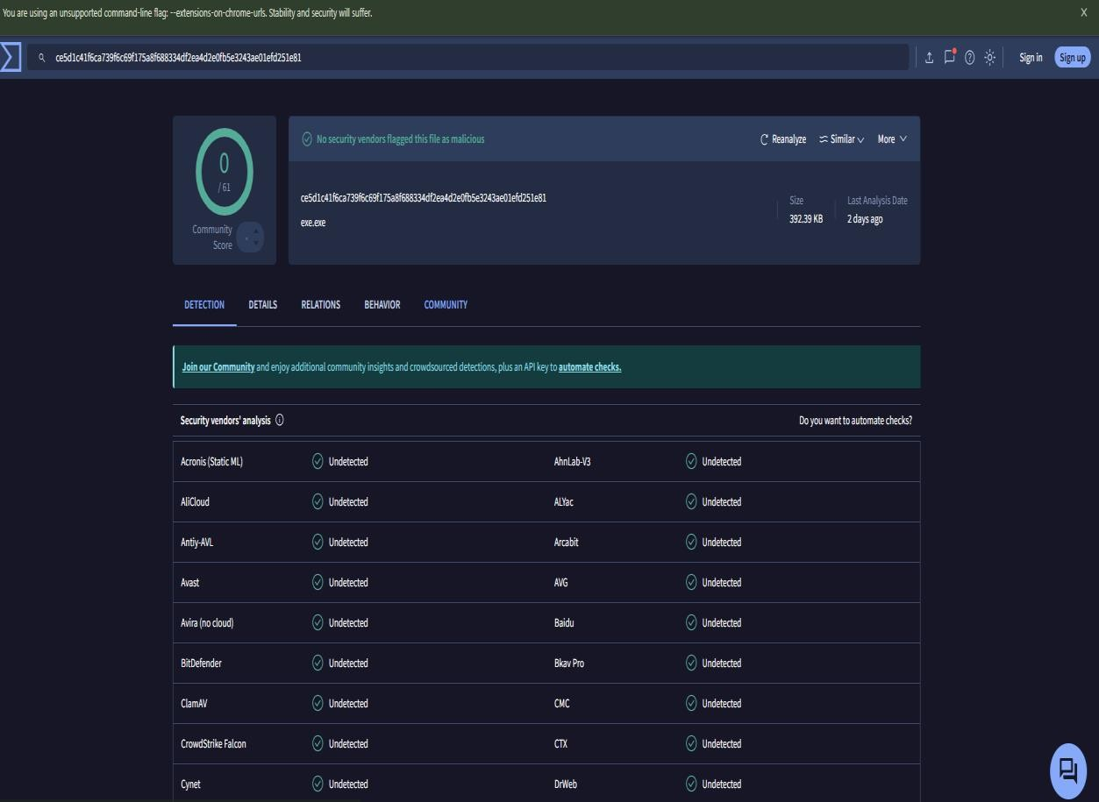

**.swf file is infected**

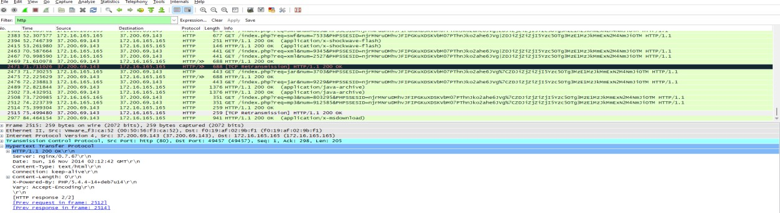**To know other details about the detected malware.What is the url of infected site? Select the packet and view the detail information**

**What is the IP address of infected website?**

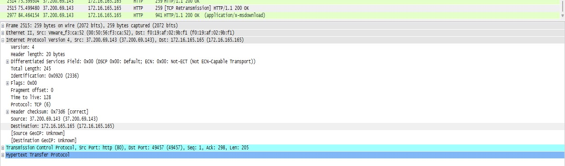

**What is the IP address of infected machine?**

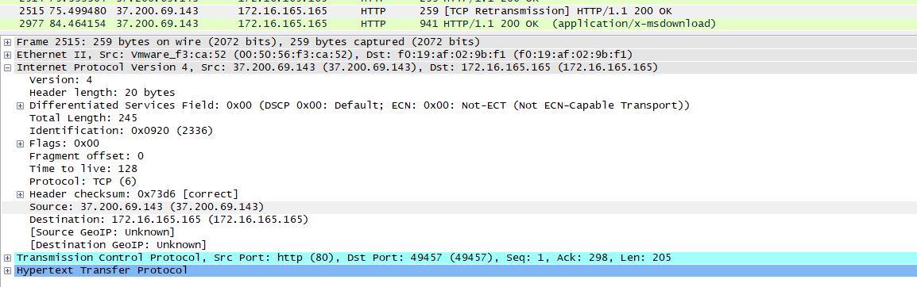

**B. Traffic Capturing and Analysis.**

Capturing Packets

**Capture traffic on your wireless network, click your wireless interface. You can configure advanced features by clicking Capture > Options, but this isn’t necessary for now.**

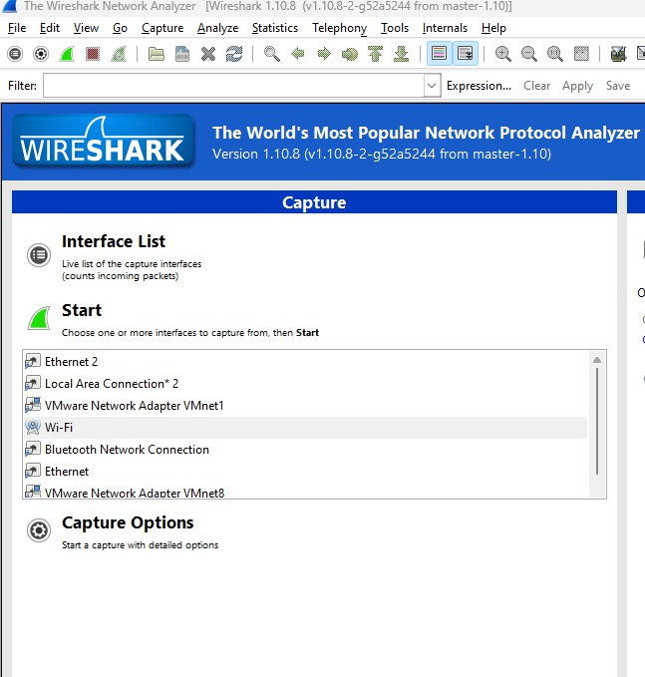

As soon as you single-click on your network interface’s name, you can see how the packets are working in real time. Wireshark will capture all the packets going in and out of our systems.

Promiscuous mode is the mode in which you can see all the packets from other systems on the network and not only the packets send or received from your network adapter. Promiscuous mode is enabled by default.

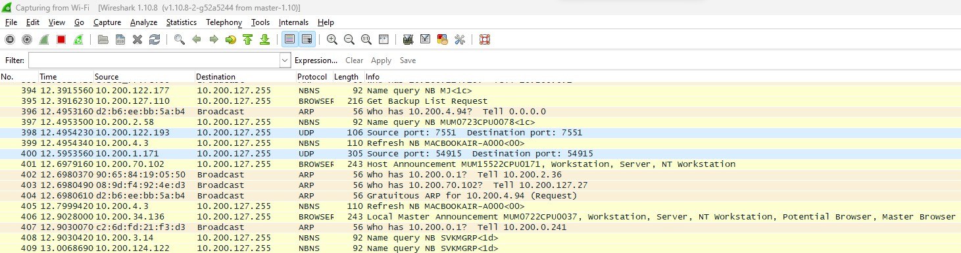

**The red box button “STOP” on the top left side of the window can be clicked to stop the capturing of traffic on the network.**

**Analyse the Capture Data**

**First of all, click on a packet and select it. Now, you can scroll down to view all its details.**

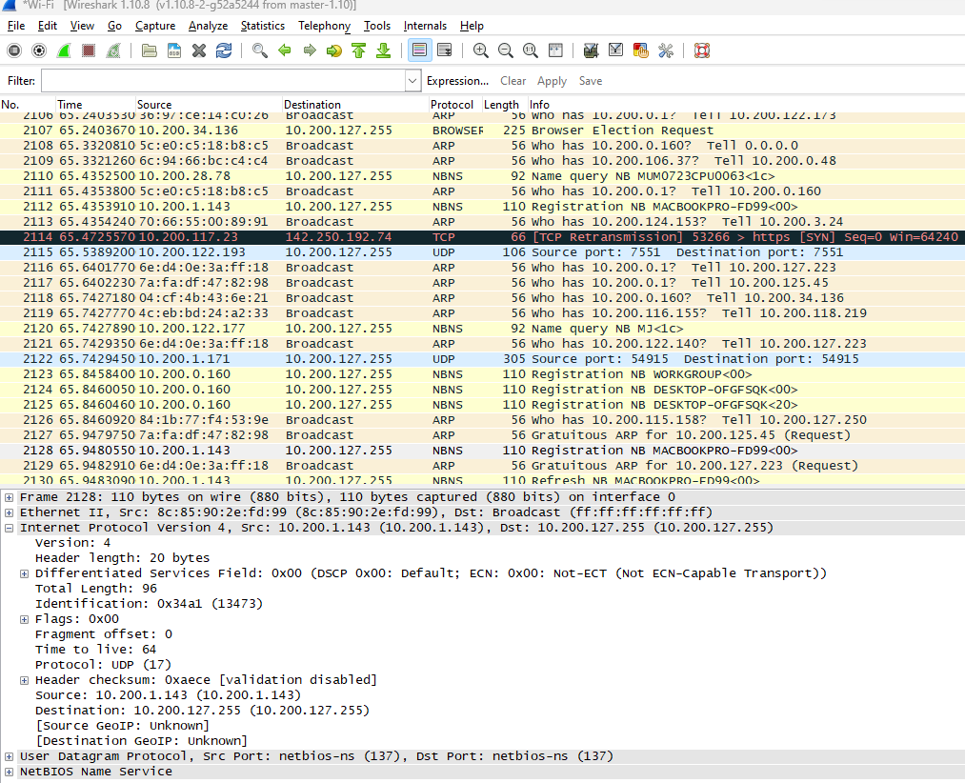

To Analyse the captured packets different filters commands are used:

1. **Display packets which are using TCP protocol tcp**

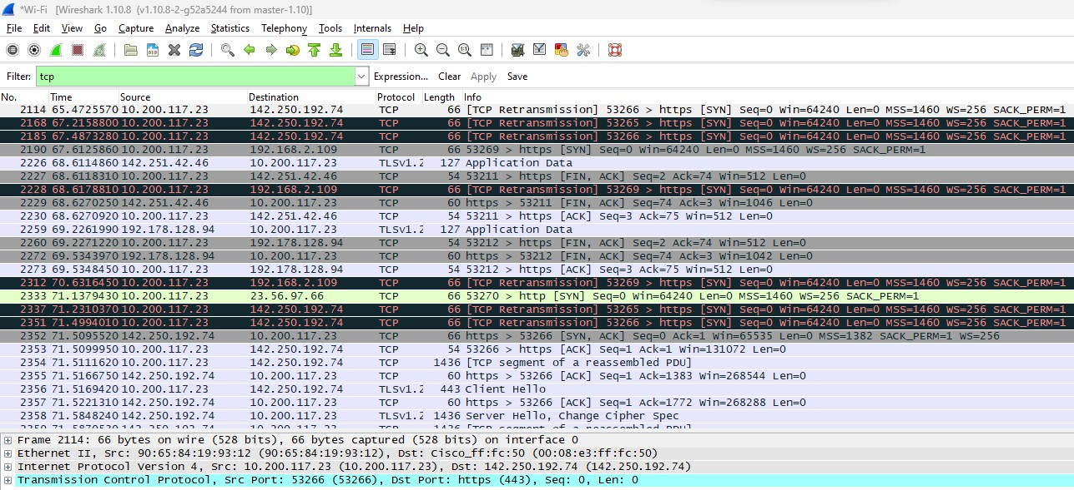

1. **Display packets which are coming from specific IP-address ip.src == 192.178.128.94**

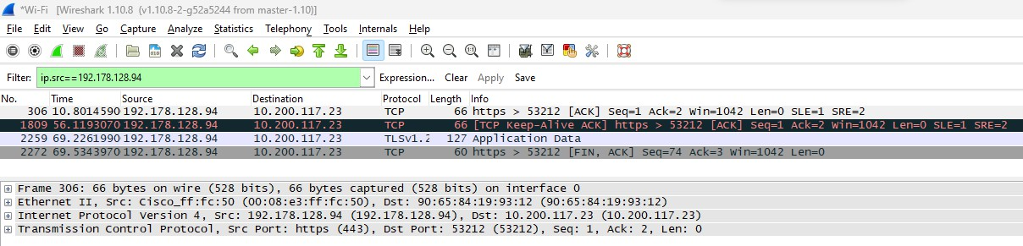

1. **Display packets which are having specific IP-address destination ip.dst == 23.212.254.51**

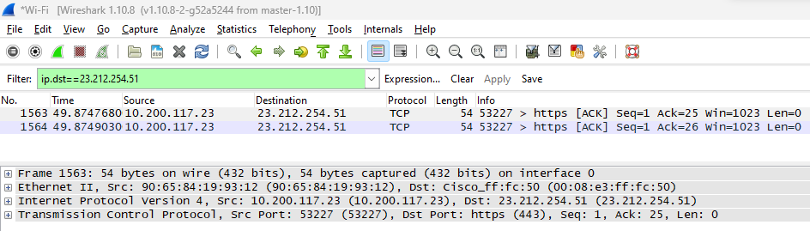

1. **Display packets having no error connecting to server ** **http.response.code==200**

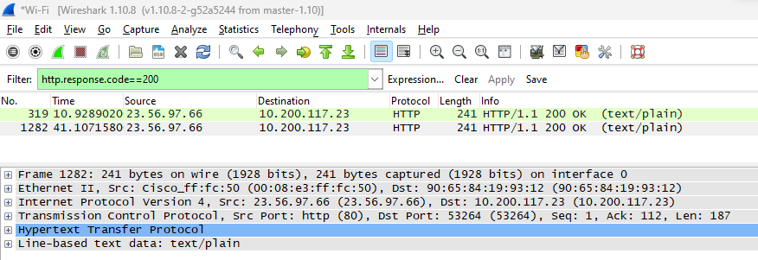

1. **Display packets which are using http request http.request**

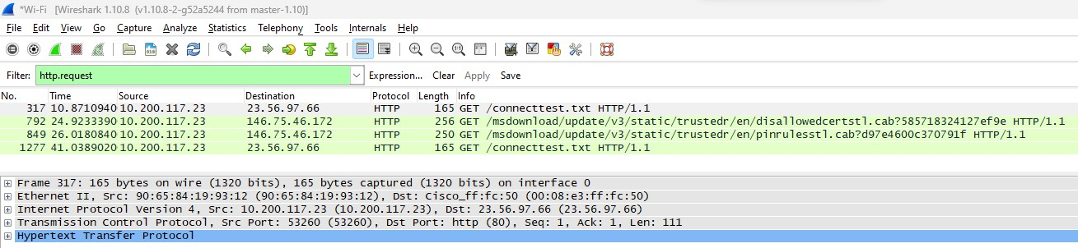

**C. Perform Network Forensic Analysis tool using NetworkMiner. Theory:**

Network Miner is an open source Network Forensic Analysis Tool (NFAT) for Windows (but also works in Linux / Mac OS X / FreeBSD). Network Miner can be used as a passive network sniffer/packet capturing tool in order to detect operating systems, sessions, hostnames, open ports etc. without putting any traffic on the network. Network Miner can also parse PCAP files for off-line analysis and to regenerate/reassemble transmitted files and certificates from PCAP files.

Network Miner makes it easy to perform advanced Network Traffic Analysis (NTA) by providing extracted artifacts in an intuitive user interface. The way data is presented not only makes the analysis simpler, it also saves valuable time for the analyst or forensic investigator.

**Step 1: Download Network miner from https://**[**www.netresec.com/?page=NetworkMiner**](http://www.netresec.com/?page=NetworkMiner)

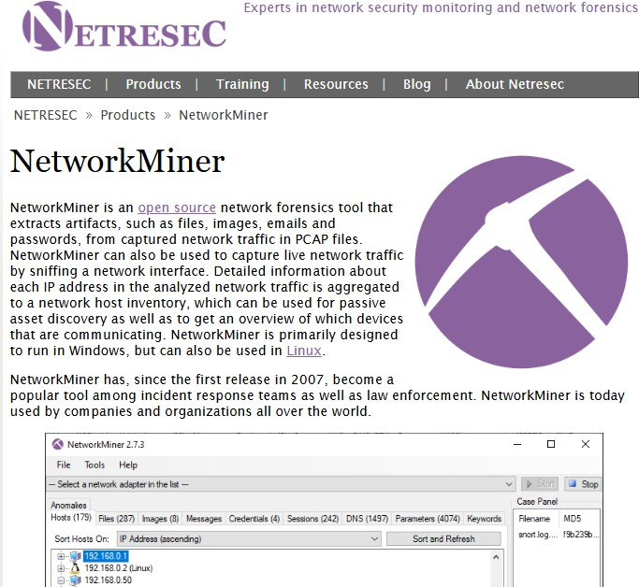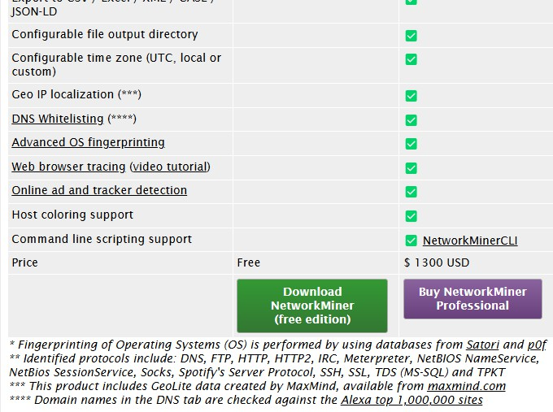

**Step 2: Extract the file from zip file contents in download folder. Open C drive- Program Files and Create a new folder- networkminer2. Copy all folder contents in this folder.**

**Step 3: Run the Application.exe file from the folder to Open Network Miner.**

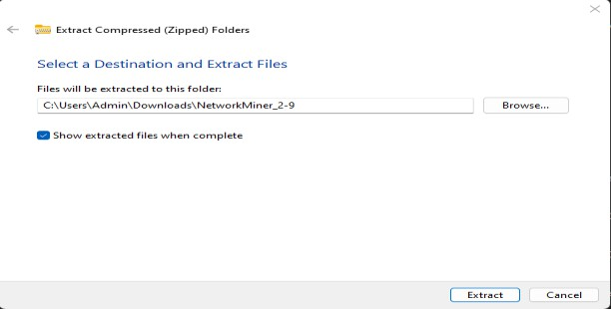

**Step 4: Download pcap file from the URL mentioned in the screenshot below** [**https://tcpreplay.appneta.com/wiki/captures.html**](https://tcpreplay.appneta.com/wiki/captures.html)

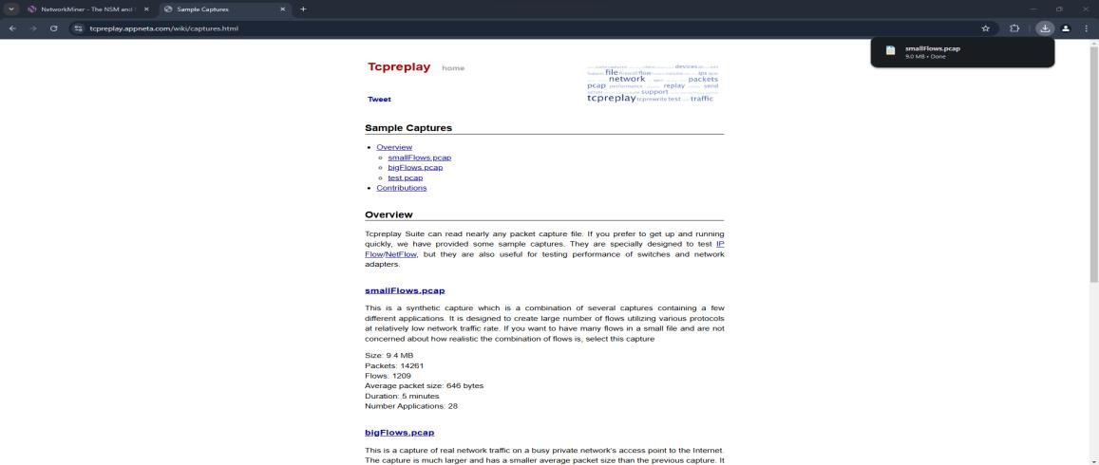

**Step 5: Open this pcap file in Network Miner. Network Miner-> File-> Open-> Select pcap file.**

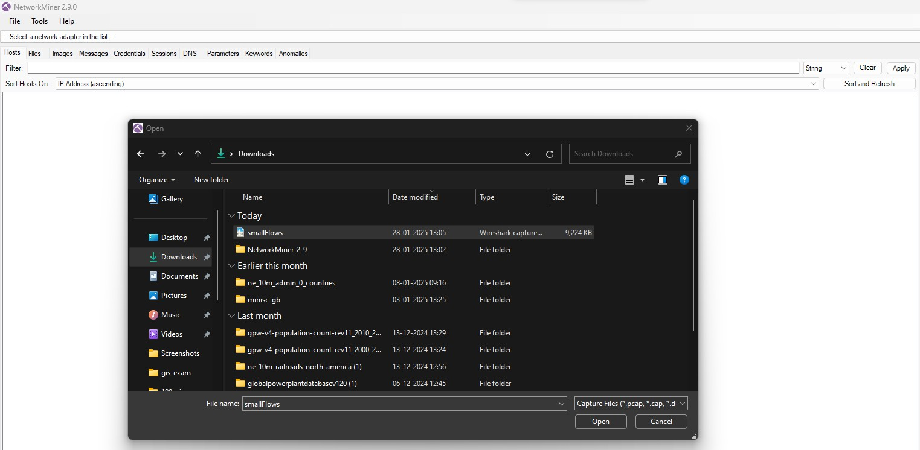

**Step 6: In the hosts tab, you can see all the host that were engaged while recording the pcap files. These pcap files could be from a recorded session of Wireshark.**

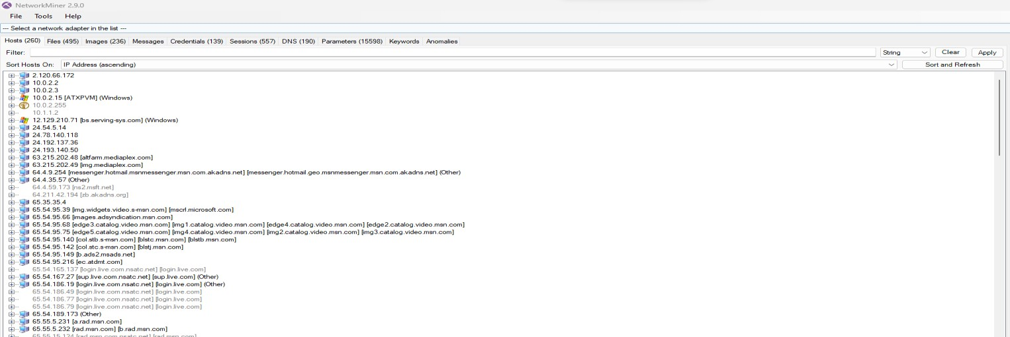

**Step 7: Open files tab to view all the files that were recorded during the pcap session.**

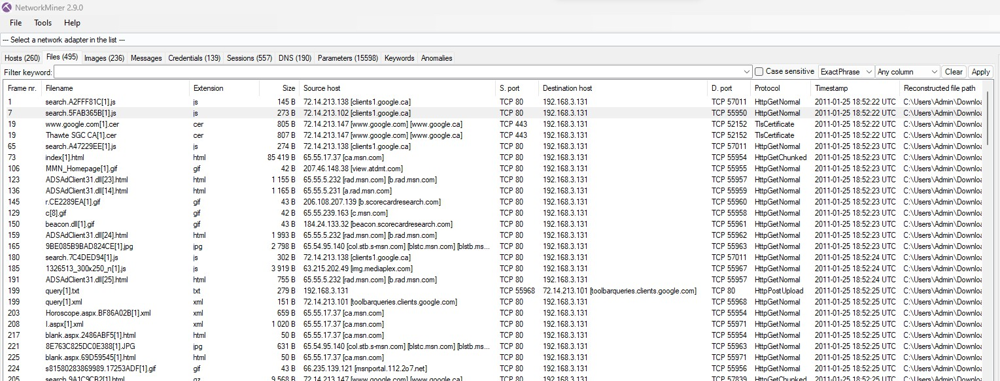

**Step 8: Right click select file details**

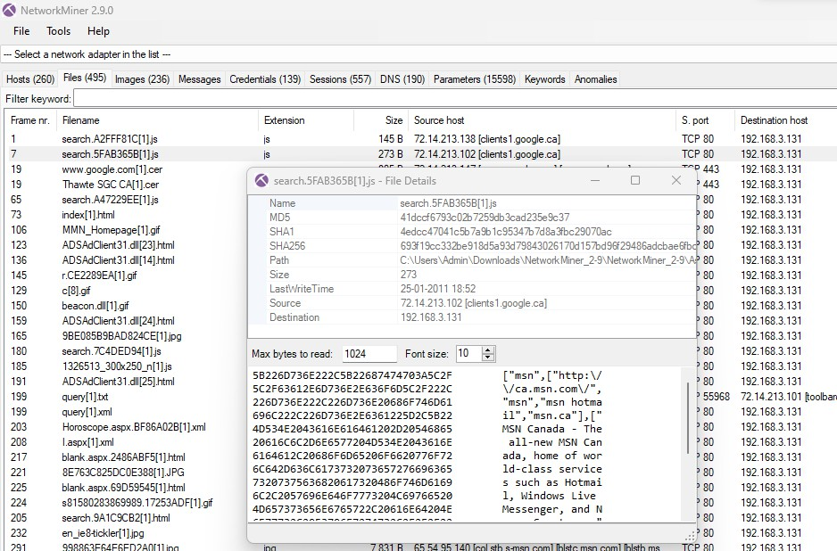

**Step 9: You can view all image below**

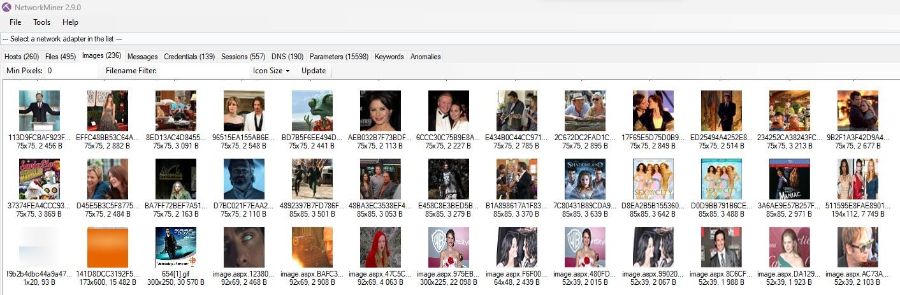

**Step 10: You can view all messages below**

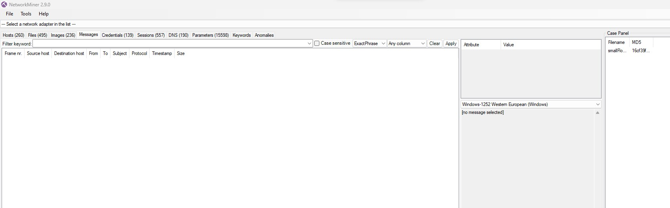

**Step 11: You can view all credentials below**

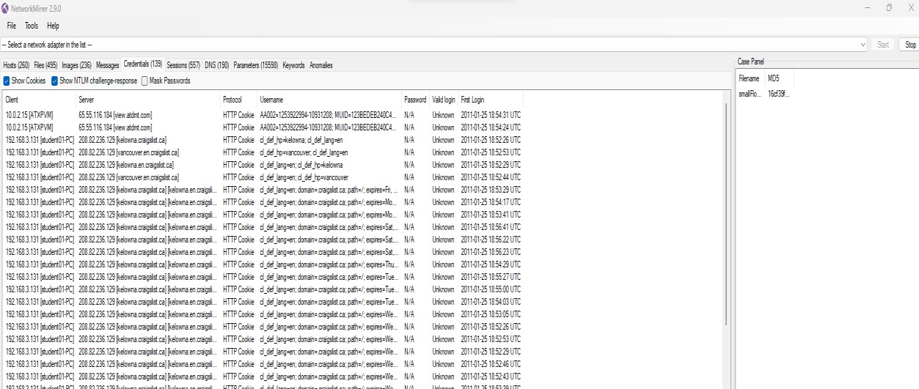

**Step 12: You can view all sessions below**

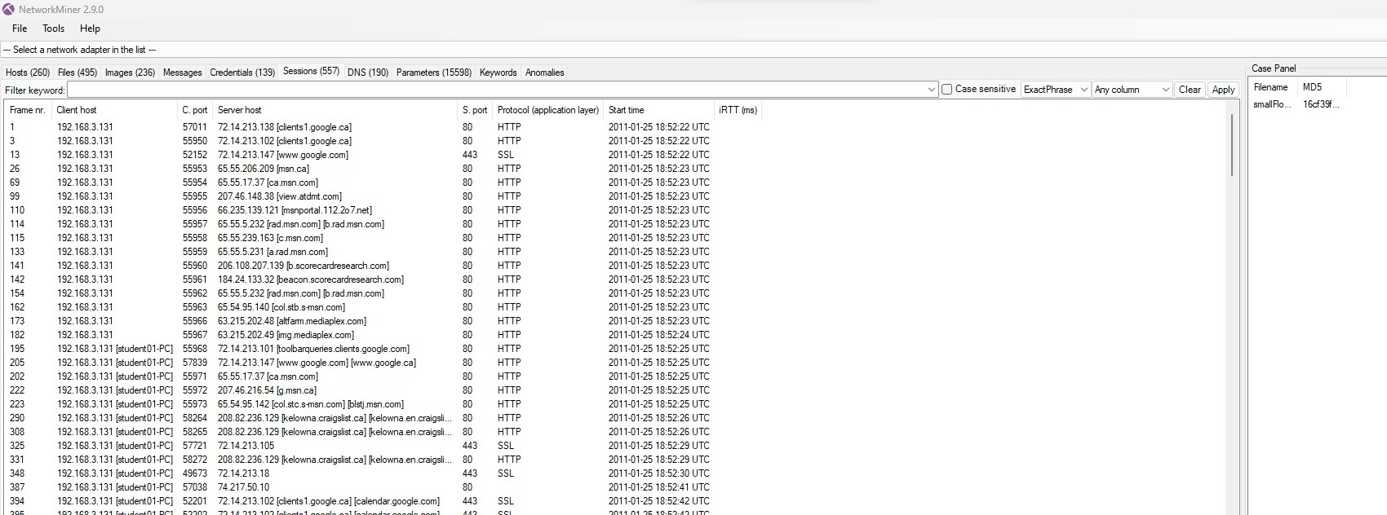

**Step 13: You can view all DNS below**

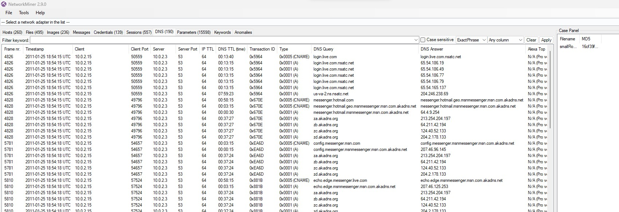

**Step 14: You can view all parameters below**

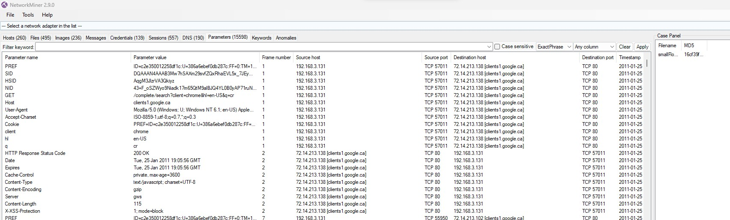

**Step 15: You can view all keywords below**

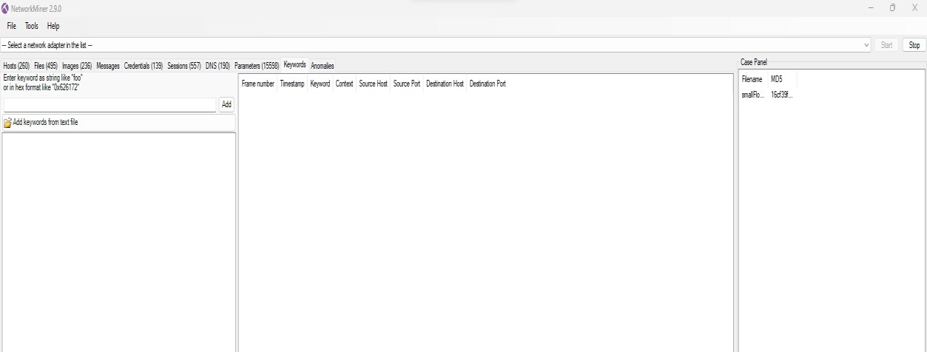

**Step 16: You can view any anomalies below**

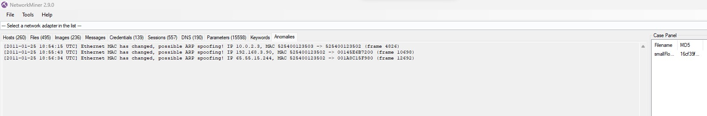

**Practical: 7 Aim: Using Data Acquisition Tools [ProDiscover] Theory**

ProDiscover Forensics is a comprehensive digital forensics software that empowers investigators to capture key evidence from computer systems. ProDiscover has capabilities to handle all aspects of an in- depth forensic investigation to collect, preserve, filter, and analyse evidence.

**Data Acquisition Tools:**

USB WRITE BLOCKER + FTK Imager

* USB Write Blocker enables you to activate or deactivate the write protection for

your USB portable devices with just a few clicks. With USB Write Blocker, you will beable to restrict the access of others to your important documents and prevent unwanted, accidental modifications that might cause data loss.

* Forensic Toolkit, or FTK, is a computer forensics software made by Access Data. Itscans a hard drive looking for various information.

**Step 1: Open ProDiscover Basic and start with new project.**

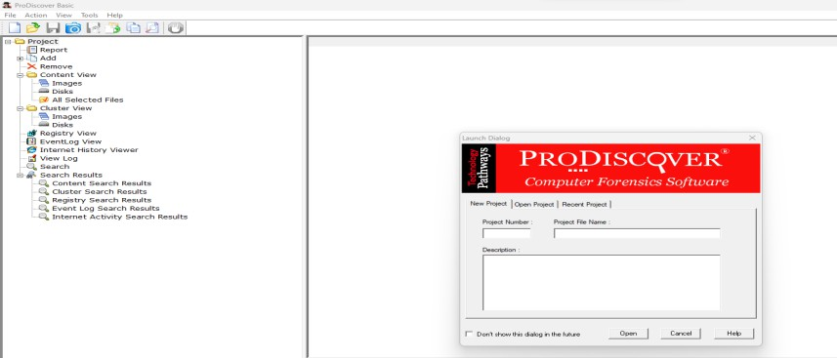

**Step 2: The new created project appears on the left side – Go on add and select Capture andAdd Image**

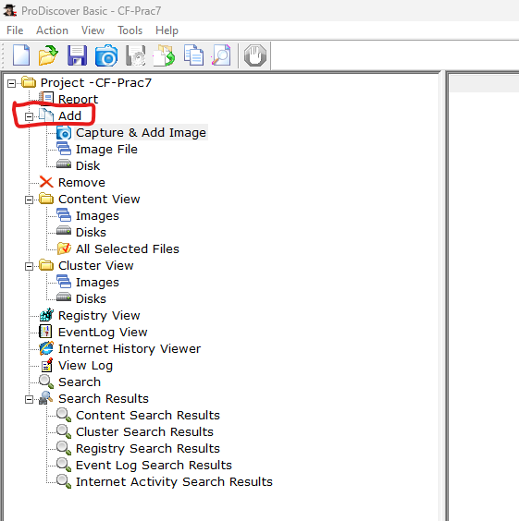

**Step 3: Select your Source Drive file from the drop down, select Destination path and add Technician Name, Image Number and Description. Click on ok**

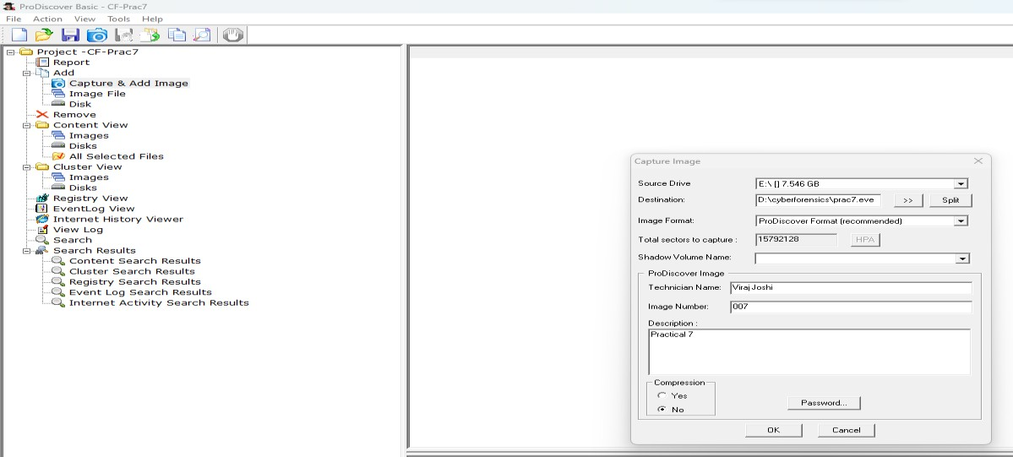

**Step 4: The image capturing will start processing.**

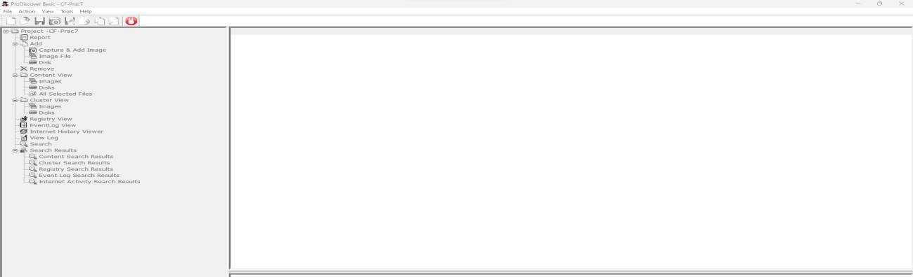

**Step 5: The image has been captured. Click on Ok**

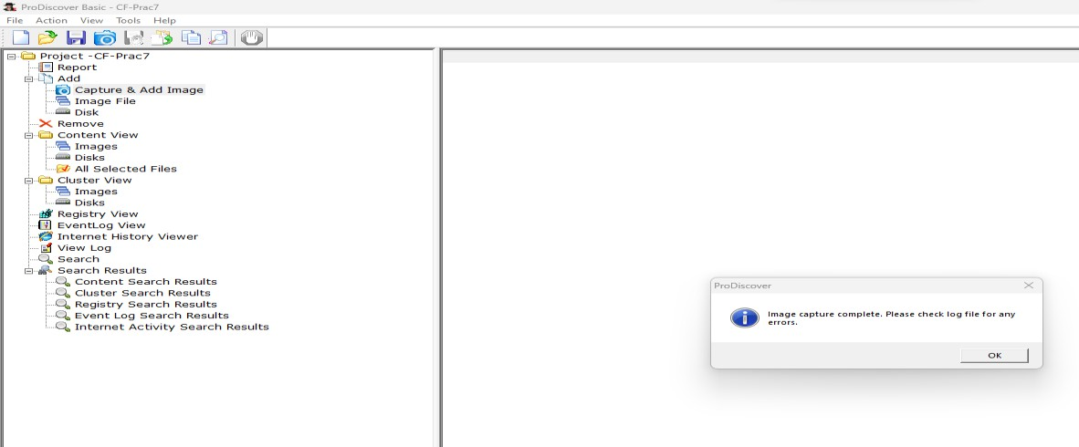

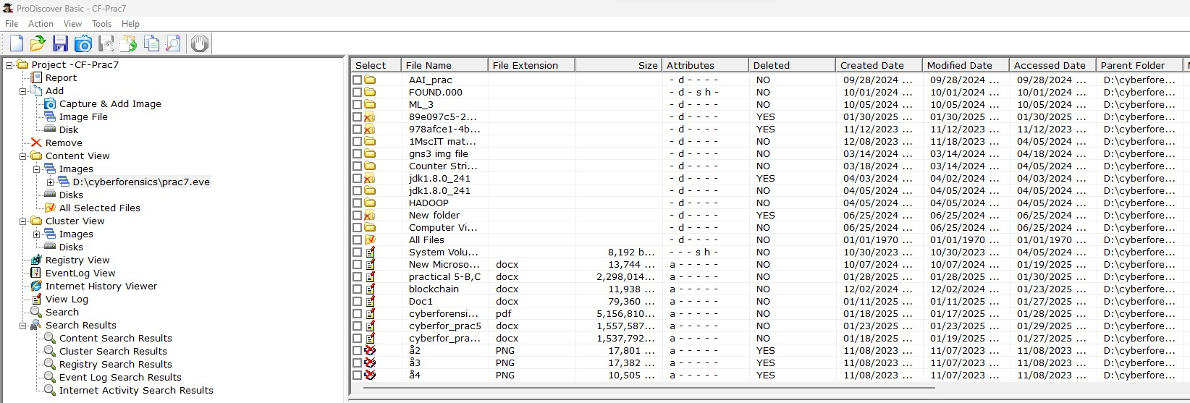

**Step 6: Click on any of the file and type a comment.**

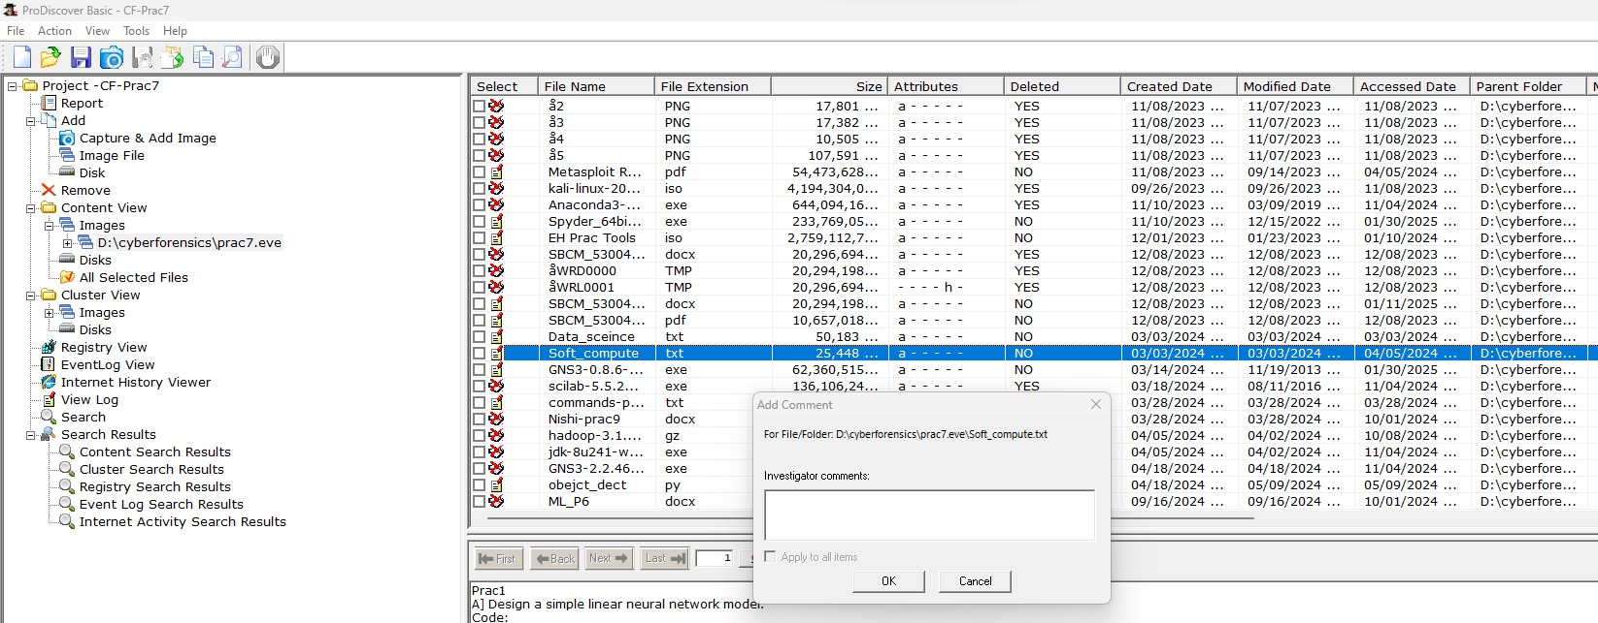

**Step 7: To see the cluster view, click on cluster view tab on the left side panel.**

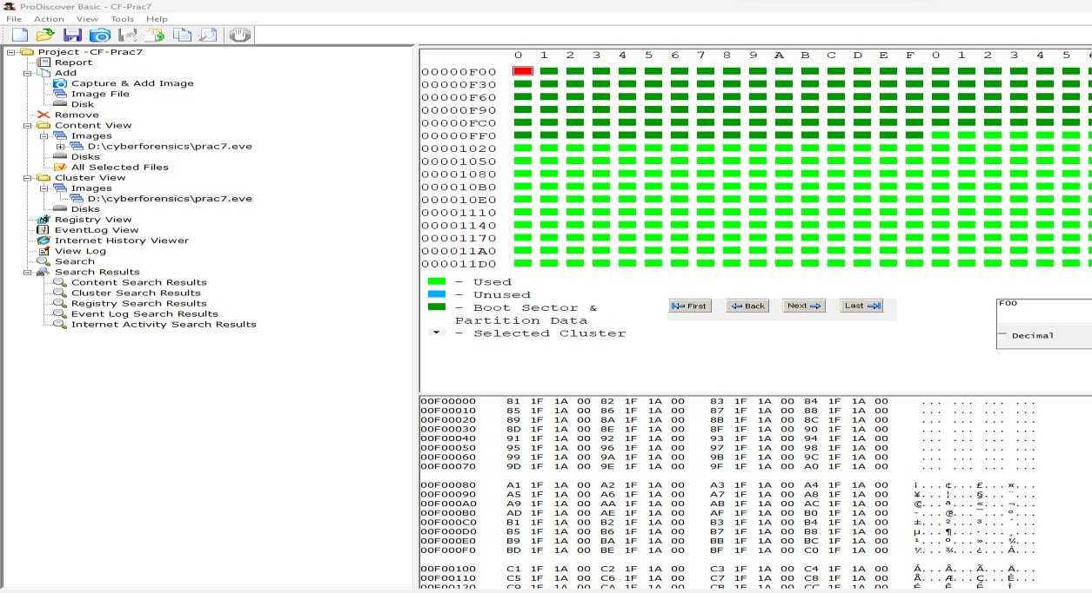

**Step 8: For Keyword Search, Click on the Search option on left side of panel and Enter the filename to be searched in the image created.**

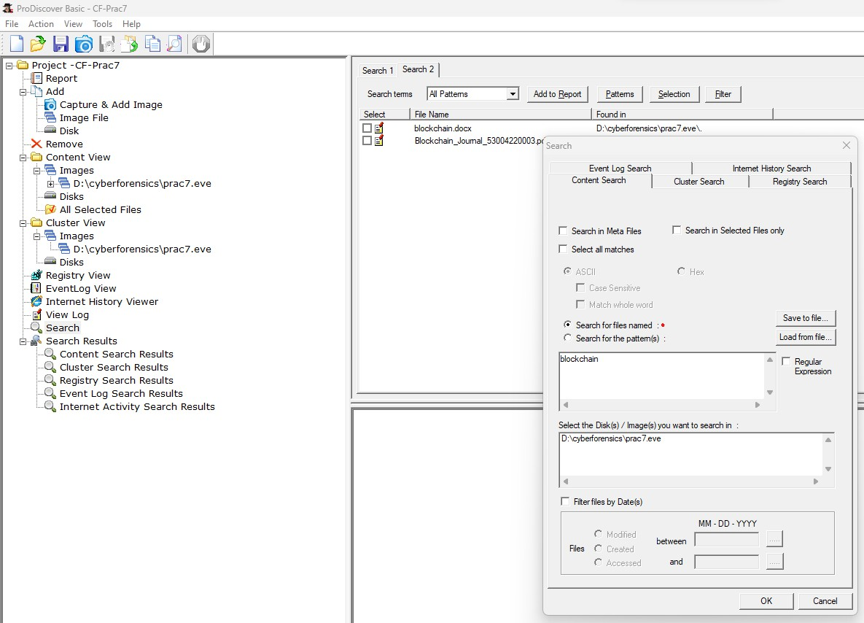

**Step 9: The following is the Output of the keyword search.**

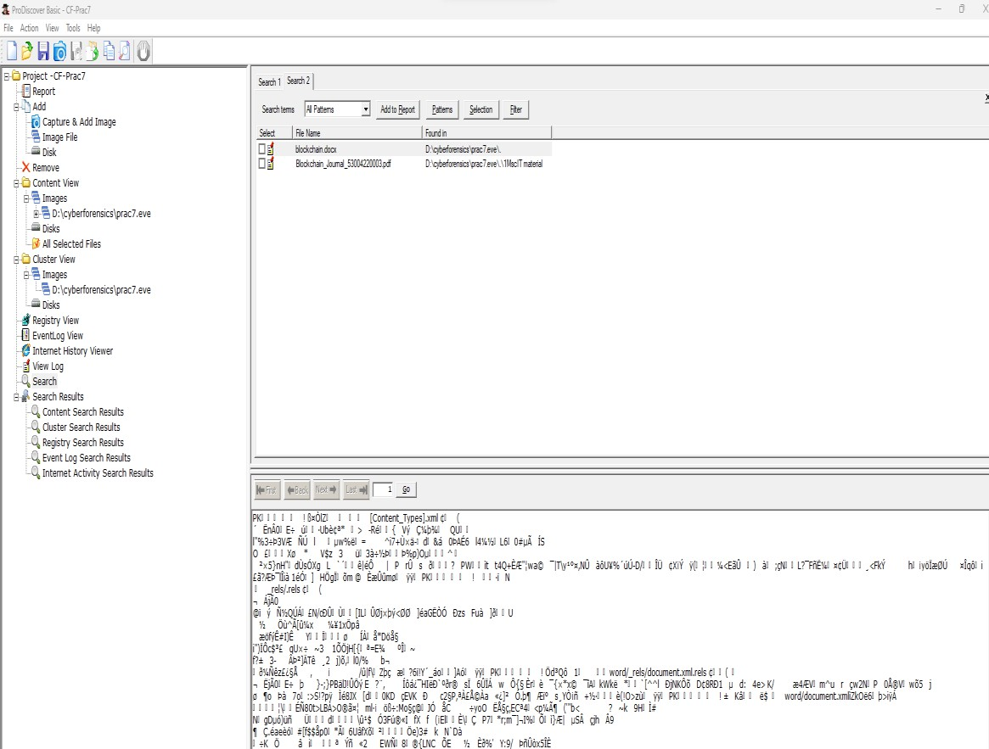

**Step 10: Click on View – Report This will show entire gist of report done in the project.**

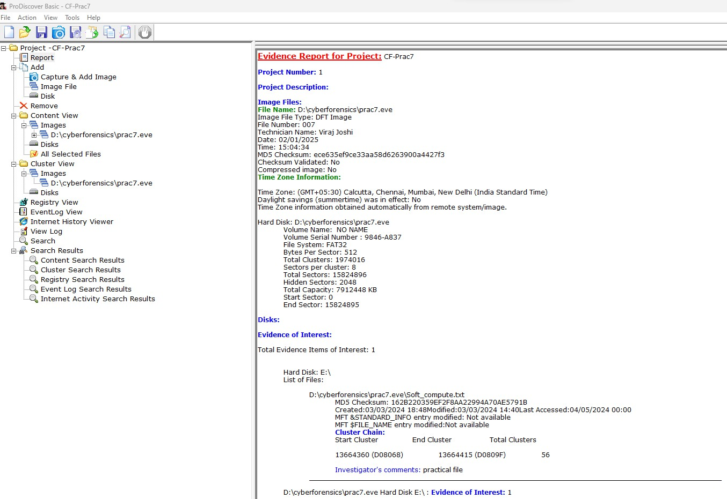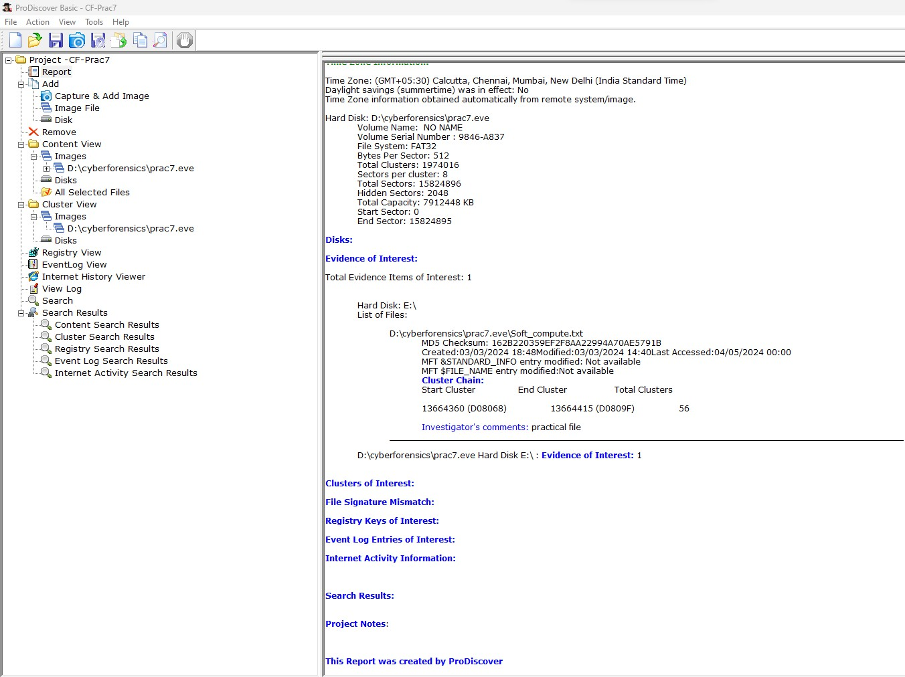

**Practical: 8 Aim: Using Steganography tool (S-Tool)**

**Theory**

Steganography is one of the oldest technique used to hide data in a image, hide image into image and hide data in a video/audio etc. You can easily hide any kind of video/audio/text/message/image into each other.

Best Tools to Perform Steganography:

There are many software available that offer steganography. Some offer normal steganography but a few offer encryption before hiding the data. These are the steganography tools which are available for free:

* Stegosuite is a free steganography tool which is written in Java. With Stegosuite you can easily hide confidential information in image files.
* Steg hide is an open source Steganography software that lets you hide a secret file in image or audio file.
* Xiao Steganography is a free software that can be used to hide data in BMP images or inWAV files.
* SSuit Picsel is another free portable application to hide text inside an image file but ittakes a different approach when compared to other tools.
* OpenPuff is a professional steganographic tool where you can store files in image,audio, video or flash files

Install the latest version of this tool Lauch stegosuite using below command

In order to encrypt an image file with a confidential file, first, you need to load the image file through the File menu.

Select a file in BMP, GIF, JPG or PNG format from the file browser and then click the OK button. The image file will be loaded in the main Stegosuite window.

You can do the following three tasks through this window:

* Enter a secret message along with the file(s) you want to embed.
* Right-click and then add a confidential file in the “embedded files” area.
* Enter a password that will be used while extracting the embedded files and a secret message, later from the image.

In order to extract the original confidential file from the image file it was embedded into, you can right- click the image file from the file browser and select “Open With Other Application from the menu and then select Stegosuite from the Select Application list as follows:

Or you can open the Stegosuite application and load an embedded image file from the File menu. Once the file is loaded, simply provide the password and click the Extract button after which, the original confidential file will be extracted back to your system.

**Step 1: Download S-tool using giving link** [**https://www.cs.vu.nl/~ast/books/mos2/zebras.html-**](https://www.cs.vu.nl/~ast/books/mos2/zebras.html-)**> then drag and drop the Zebra.bmp image**

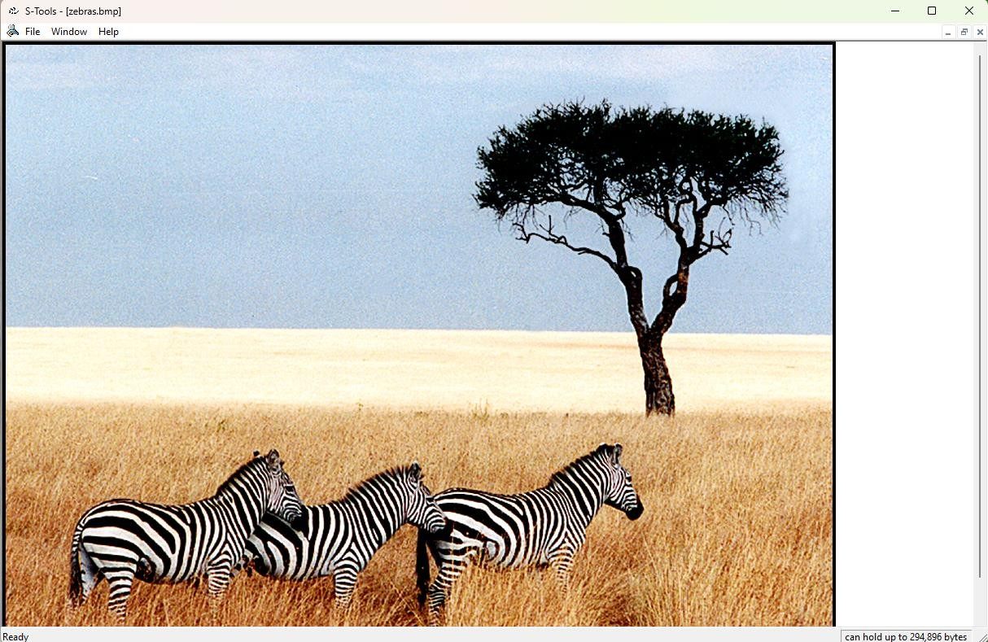

**Step 2: Create a new text document-> Type anything inside it and save it**

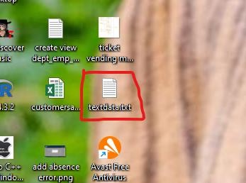

**Step 3: Now drag and drop the text file on the image-> enter the password**

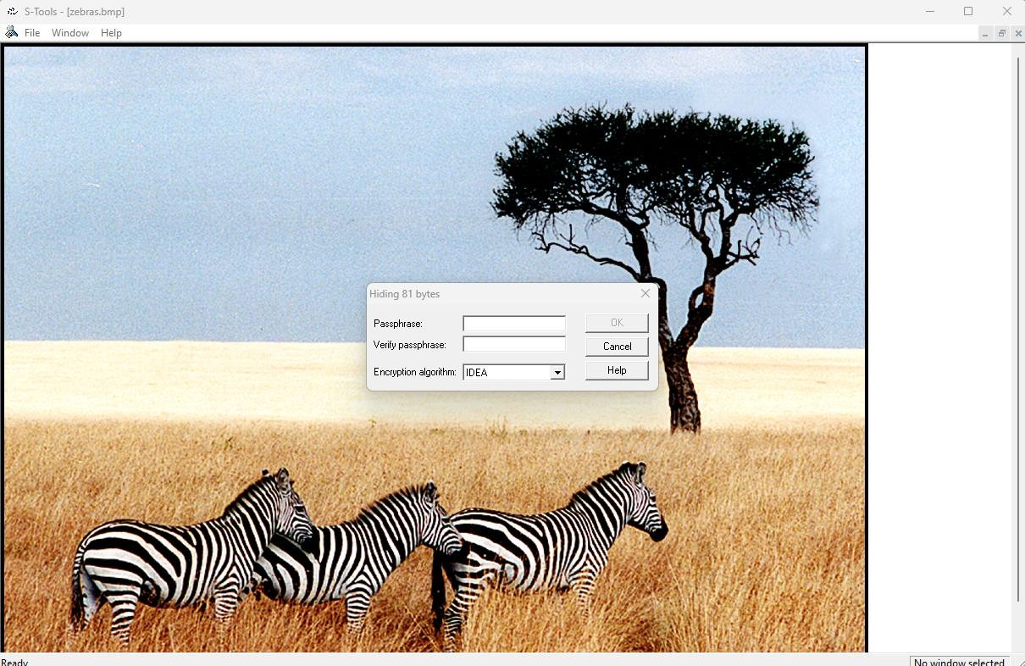

**Step 4: Now save the file**

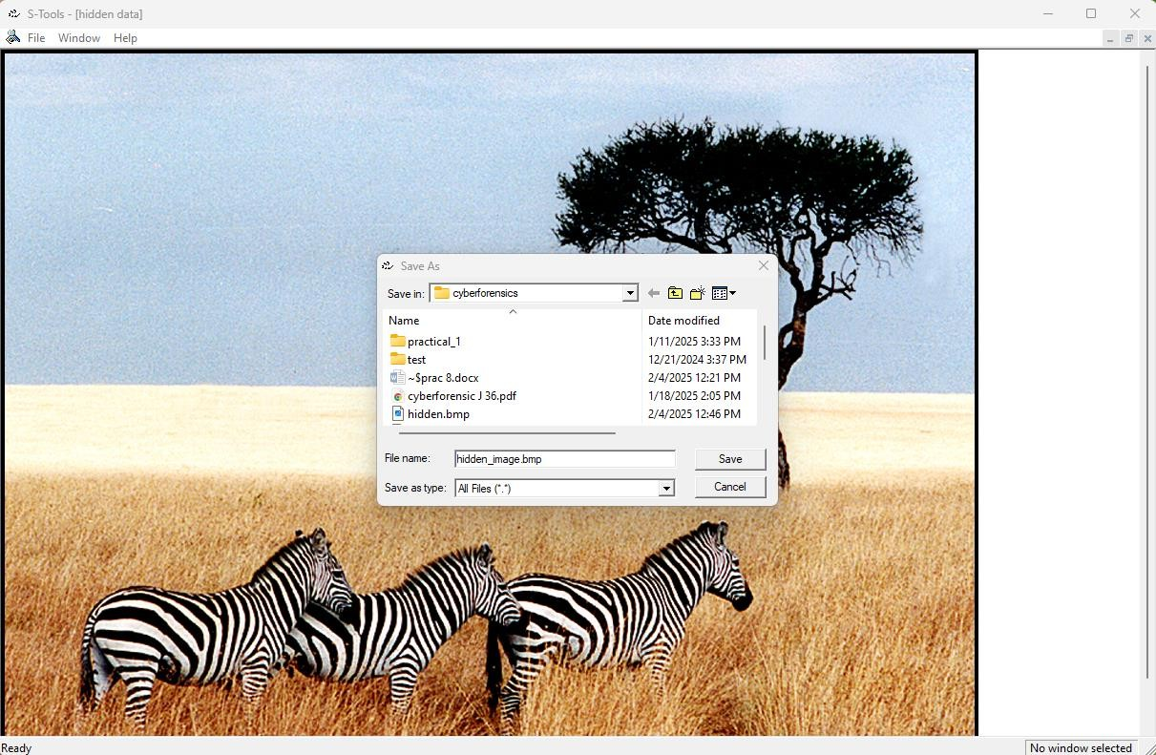

**Step 5: Open saved image -> right click on it-> Revel…**

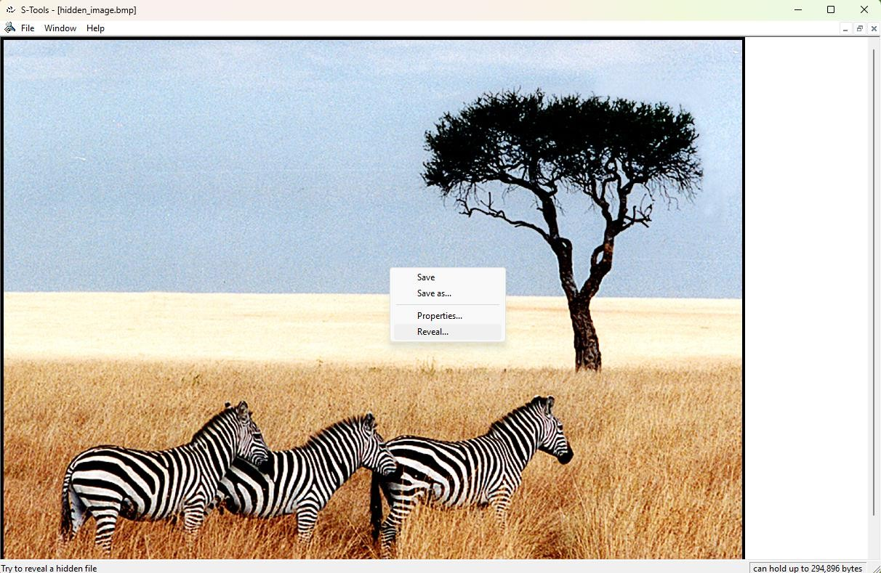

**Step 6: Enter the password that you have created**

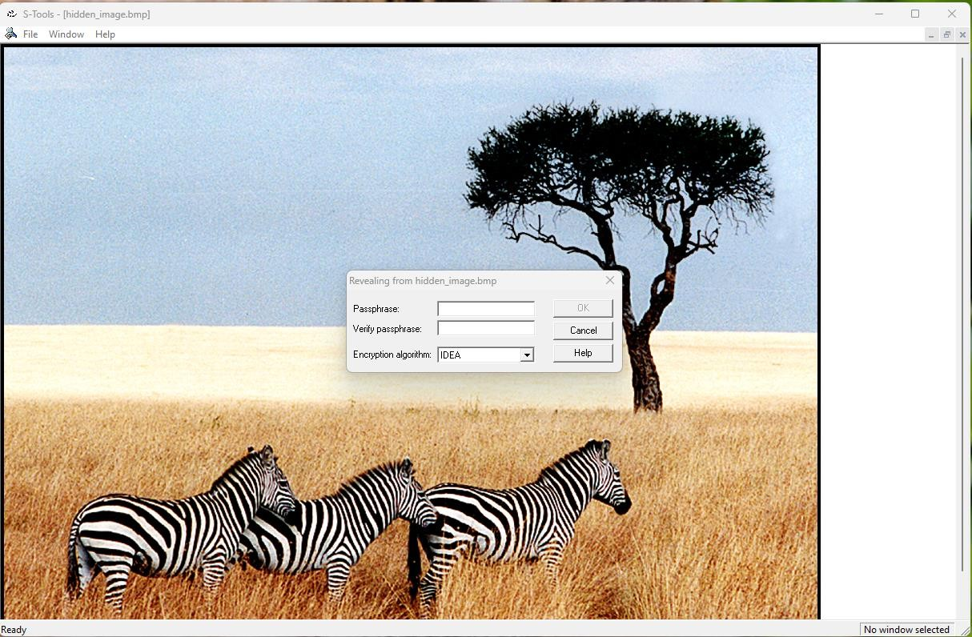

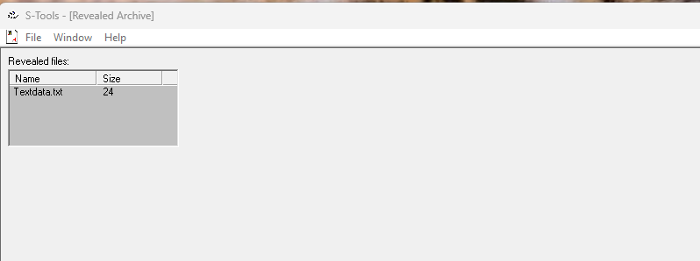

**Step 7: Now save the Text file (TextData) file**

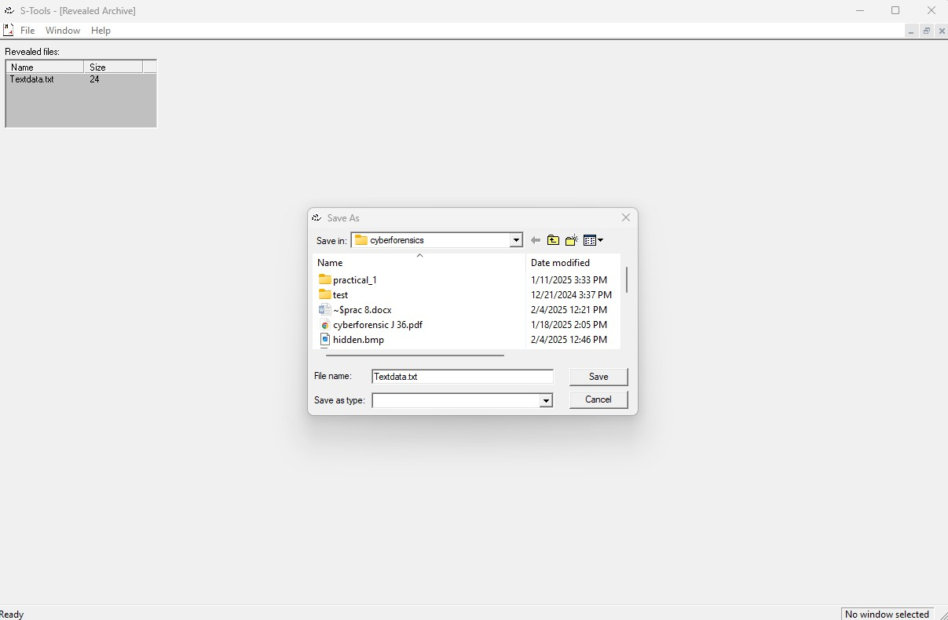

**Practical: 9**

**Aim: (A) Performing Password Cracking [Cain & Abel]. Theory**

Cain & Abel is a tool that will be quite useful for network administrators, teachers, professional penetration testers, security consultants/professionals, forensic staff and security software vendors.

**Step1:Download Cain n able software using the given link** [**http://www.oxid.it/downloads/ca_setup.exe**](http://www.oxid.it/downloads/ca_setup.exe) **Now it’s time to speak about the cracker tab,the most important feature of Cain. When Cain captures some LM and NTLM hashes or any kind of passwords for any supported protocols, Cain sends them automatically to the Cracker tab. We will import a local SAMfile just for demonstration purposes to illustrate this point. Here is how to import the SAMfile**

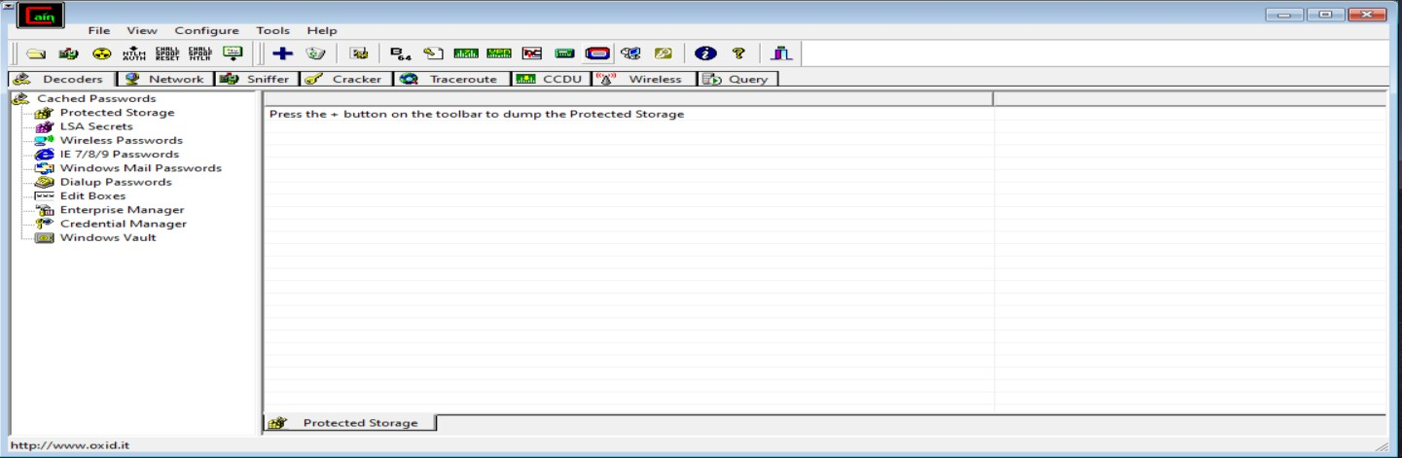

**Step 2: Click on Craker-> then plus icon-> then LM & NTLM head**

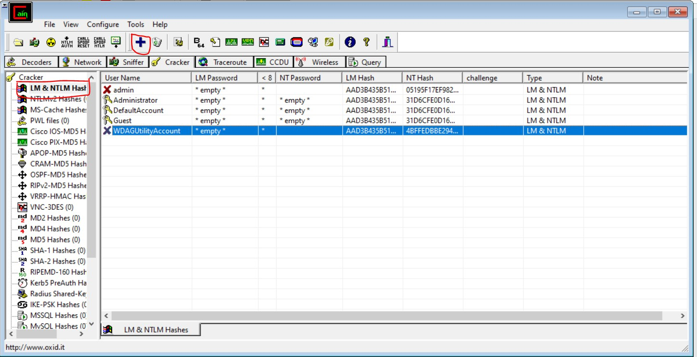

**Step 3: Now right click on WDAG**

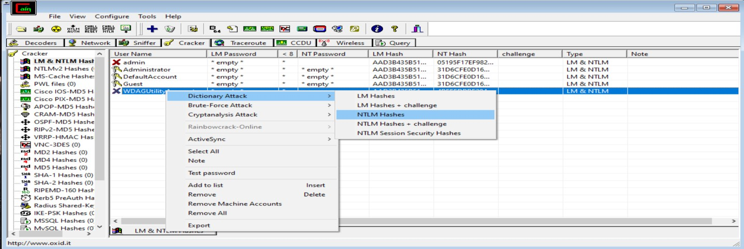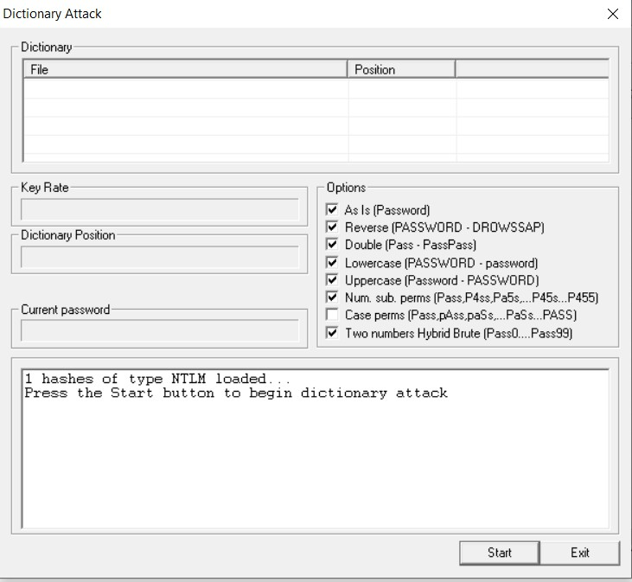

**Step 4: Choose a file 10-million passwords.txt (you will get on github)-> click on start**

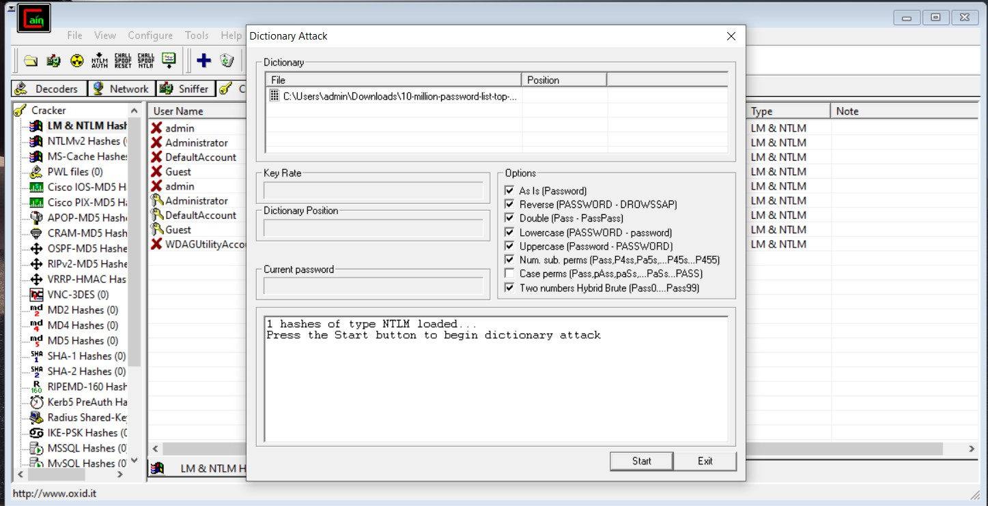

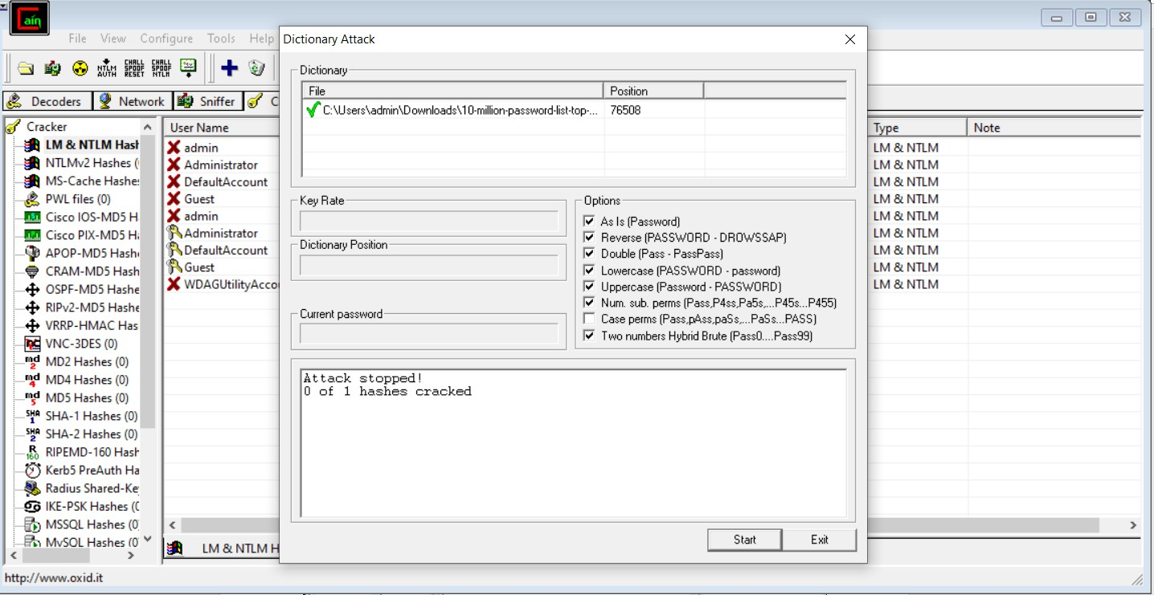

1. **Performing Sniffing [Cain & Abel]. Theory**

Sniffing:

A packet analyser (also known as a network analyser, protocol analyser or packet sniffer, or for particular types of networks, an Ethernet sniffer or wireless sniffer) is a computer program or a piece of computer hardware that can intercept and log traffic passing over a digital network or part of a network. As data streams flow across the network, the sniffer captures each packet and,if needed, decodes the packet’s raw data, showing the values of various fields in the packet, andanalyses its content according to the appropriate RFC or other specifications.

**Step 1: Go to -> Sniffer Tab and click Configure in the main menu to configure your packet listening adapter.**

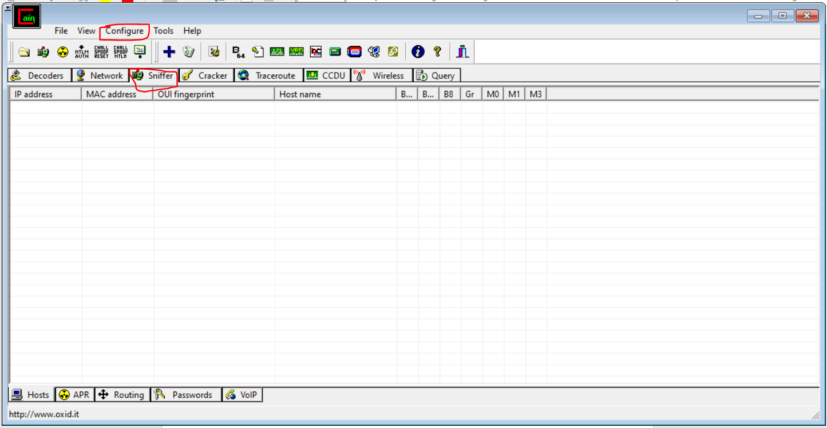

**Step 2: Select the appropriate network adapter for your network that you want to sniff the packets forplain-text passwords. And Click Ok**

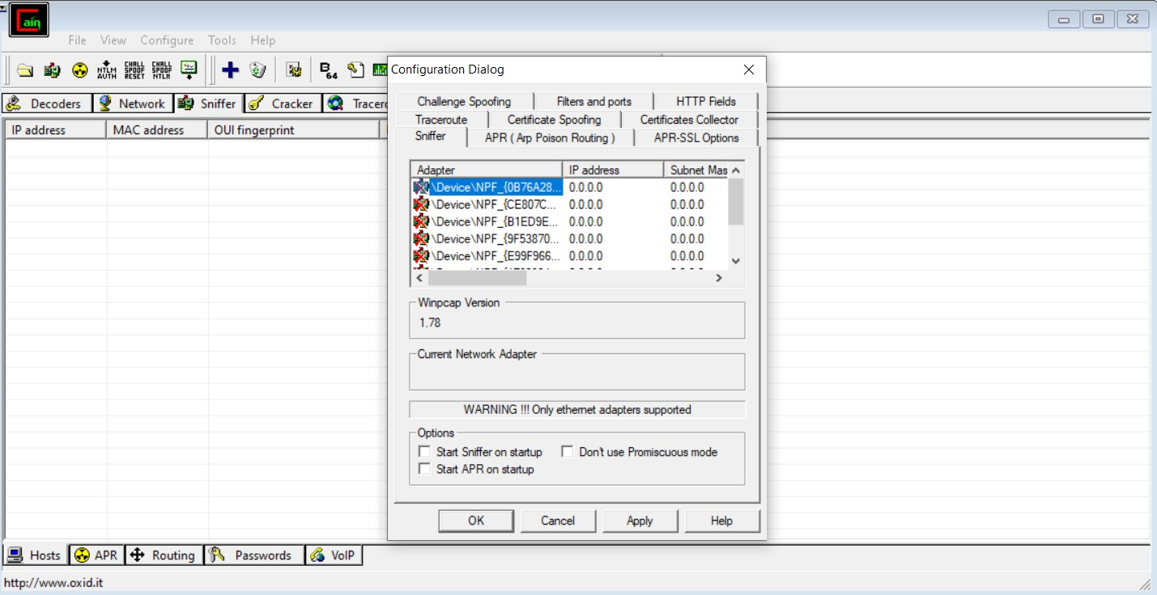

**Step 3: This is very interesting step. Now we need to select the router`s IP address and click ok. This means that we want to listen to every packet that is sent to router. If we select any other IP address in our LAN network then we can listen to only that particular HOST on the network.**

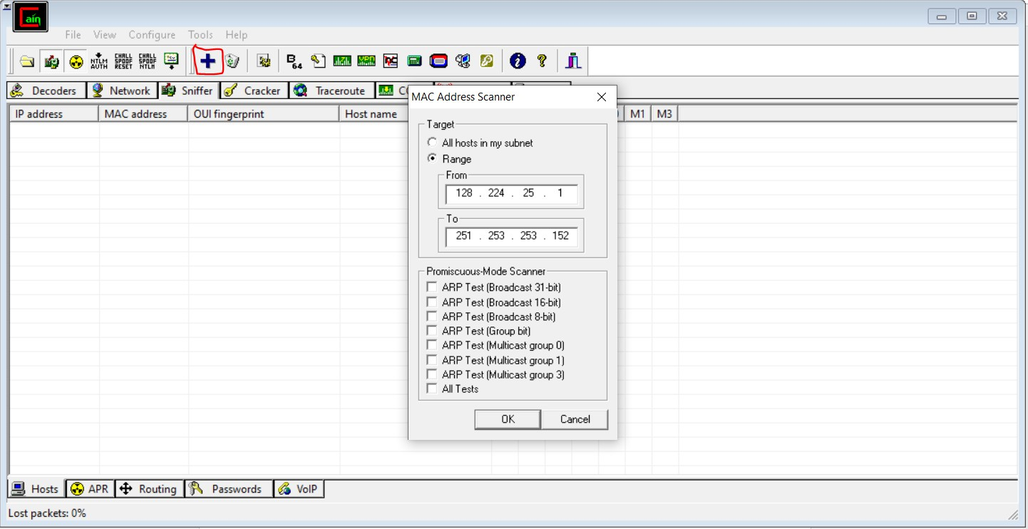

**Step 4: After Scanning Mac Address. You will finally get the Output.**

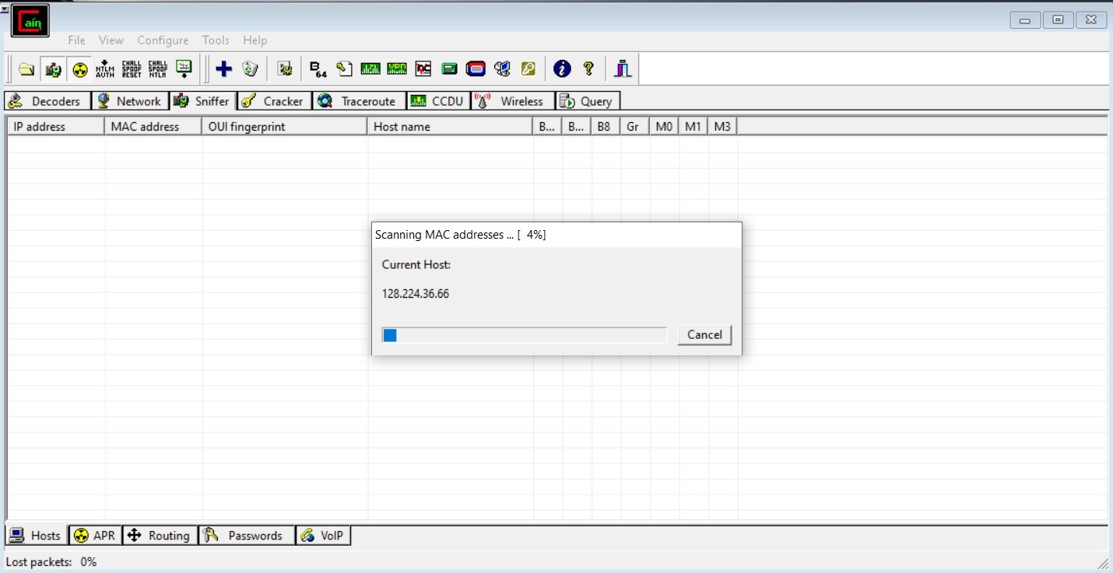

**Practical: 10 Aim: B) Scan Registry using RegScanner.**

**Theory**

RegScanner is a small and lightweight system utility, which allows you to scan the Registry,

findthe desired Registry values that match the specified search criteria and then displays them in a list.

* 1. Problem Statement

A registry scanner or registry cleaner is third-party software for Microsoft Windows that

searchesfor registry items that are redundant or no longer needed, then removes or resolves them. The objective is to help the system work more efficiently by "cleaning" it of these

superfluous registryentries. II.Literature/Theory

Some Registry cleaners make no distinction as to the severity of the errors, and many that do may erroneously categorize errors as "critical" with little basis to support it.[1] Removing or changing certain Registry data can prevent the system from starting, or cause application errorsand crashes

**Step 1: Install RegScanner > Double click on RegScanner .exe file to run the application.**

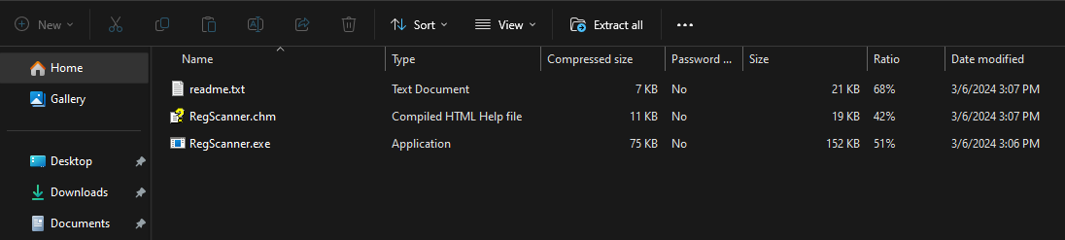

**Step 2: Quickly scan your registry and you can also search for the specific values with RegScanner.. You can select to scan the base keys**

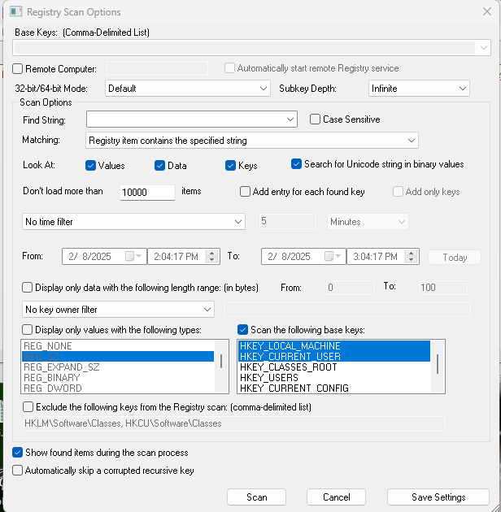

**Step 3: In Matching drop-down > Select Registry item contains the specified string -> Type(int)**

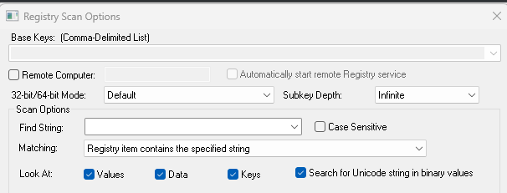

**Step 4: Scan Result / Output:**

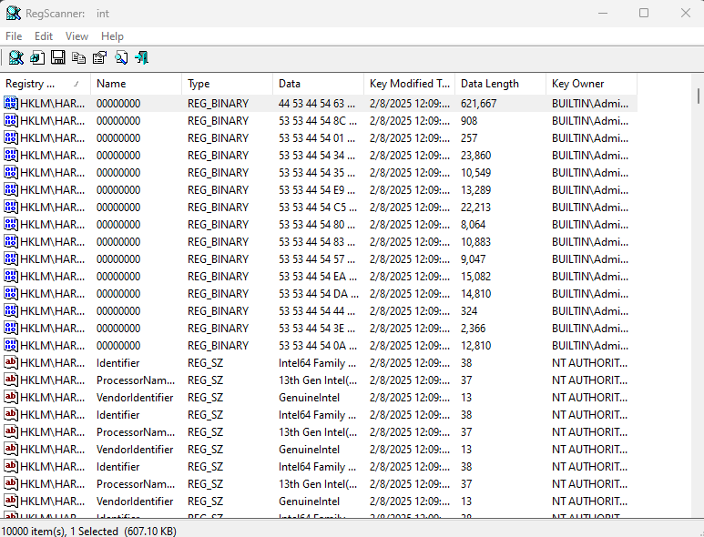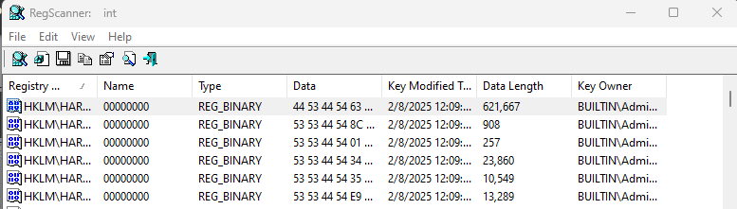

1. **Study Registry Viewer tool (Alien Registry Viewer). Theory**
   1. Title

Alien Registry Viewer allows you to explore registry files, search for specific key names and values, export registry data into a. REG or text file and bookmark registry keys as favorites. As well as the above mentioned files, Windows uses hidden files with the same names and extensions.

* 1. Problem Statement

Registry Viewer allows you to view the protected storage of a registry. Passwords,

usernames, and other information can be stored in the secured storage, which is not accessible using the Windows Registry Editor. Registry Viewer comes with a number of tools for

retrieving and reporting vital registry data. III.Literature/Theory

Alien Registry Viewer is similar to the RegEdit application included into Windows, but

unlike RegEdit, it works with standalone registry files. The current version of Alien Registry Viewer works in the read-only mode, i.e. you can view but you cannot edit registry files.

**Step 1: Install the Alien registry viewer by double clicking on the .exe file.-> The following window would appear.Click on Next.**

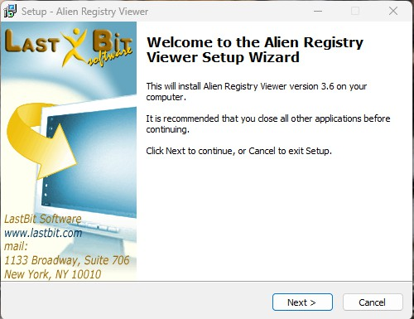

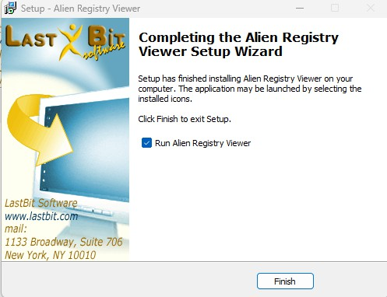

**Step 2: After installation the following window would appear.**

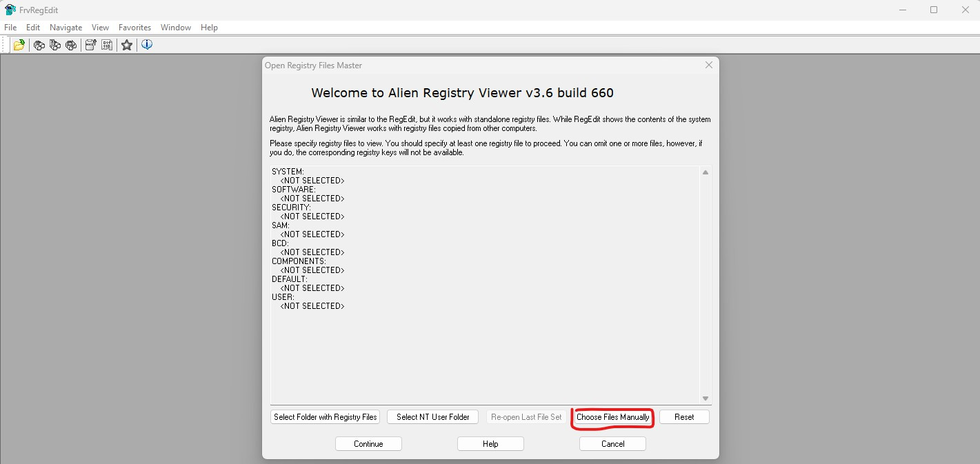

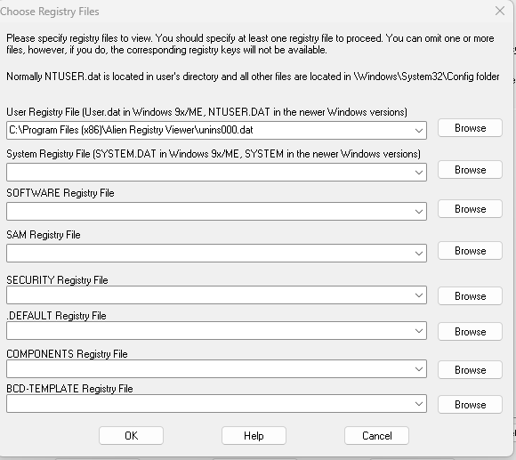

**Step 3: Click on HKEY_CLASSES_ROOT HKEY_CURRENT_USER…. etc**

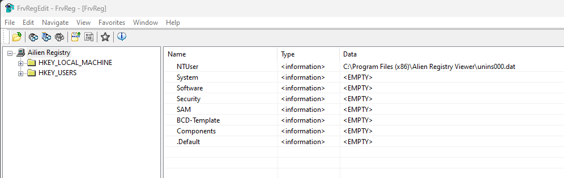

**Step 4: Press CTRL + F. The following dialog box will appear.in Find what textbox type**

**.pdf > Click Find Next.**

